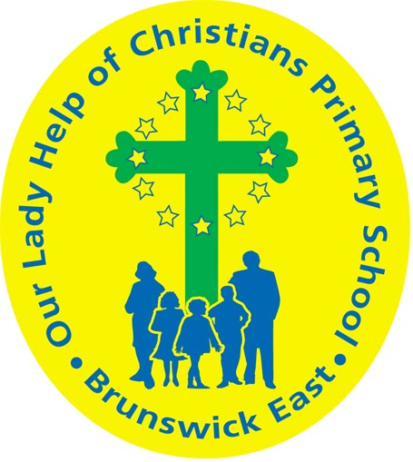
Our Lady Help Of Christians
Term Four 2025 Overview

Year Level: Six Teachers: 6P Mary Papworth 6P mpapworth@olbruswickeast.catholic.edu.au
6C Nyree Clyne ( Mon - Thu) nclyne@olbruswickeast.catholic.edu.au &
6C Damien Murray (Fri) dmurray@olbruswickeast.catholic.edu.au

Over the term, the students will be working towards the learning outcomes and concepts outlined below.
RELIGIOUS EDUCATION  In Religion this term, students will focus on the meaning of Christmas as a time of preparation, giving and hope. They will be learning about the season of Advent and taking part in activities that help them prepare for Christmas in a thoughtful and faith-filled way.  As part of living out the values of generosity and compassion, students will help create a Christmas Market. They will design and make items to sell, with the money raised going to support marginalised people in our community. Students will also research different organisations that provide help for the less fortunate, learning about the important work they do in our community and beyond.  The students will be:  - interpreting the meaning of the scripture  - participating in reflections using the Dialogical Model  - preparing for Christmas by analysing the symbols and themes of Advent  - planning and preparing a stall for the Christmas market to raise money for a local Catholic outreach organisation.   | ENGLISH  READING & VIEWING  The students will be:  - analysing the text structures and language features used in poetry and narratives  - developing comprehension strategies including visualising, summarising and inferring  - finding the main idea and supporting details  - identifying the strategy of comparing and contrasting.  WRITING  The students will be:  - planning, drafting and editing poetry pieces and narrative texts    - looking in detail at the structure and language features of poetry and narrative texts  - organising their thinking and ideas for writing by using a Writer’s Notebook  - creating an editing criteria focussing on text sequence, punctuation and spelling  - practising fluency, style and correct letter formation when handwriting.  SPEAKING & LISTENING  The students will be:  - creating a variety of sequenced texts for different purposes and audiences  - planning and presenting a text using multimodal elements.
MATHEMATICS  NUMBER  The students will be:  - selecting and applying efficient mental and written strategies and appropriate digital technologies to solve problems involving all four operations with whole numbers  - making estimates for these computations  - exploring the use of brackets and order of operations to write number sentences  - solving addition and subtraction problems involving fractions with related and unrelated denominators.  - recognising situations, including financial contexts, that use solving number problems  - solving problems that require finding a familiar fraction, decimal or percentage of a quantity, including percentage discounts  - choosing efficient calculation strategies.  ALGEBRA  The students will be:  - recognising and using rules that generate visually growing patterns and number patterns involving rational numbers  - finding unknown values in numerical equations involving brackets and combinations of arithmetic operations, using the properties of numbers and operations.  MEASUREMENT  The students will be:  - interpreting and using timetables  - measuring, calculating and comparing elapsed time  - interpreting and using timetables and itineraries to plan activities and determine the duration of events and journeys.  SPACE  The students will be:  - locating points in the four quadrants of the Cartesian plane  - describing changes to the coordinates when a point is moved to a different position in the plane.  STATISTICS  The students will be:  - planning and conducting statistical investigations by posing and refining questions to collect categorical or numerical data by observation or survey  - identifying a problem and collecting relevant data  - analysing and interpreting the data and communicating findings within the context of the investigation.  PROBABILITY  The students will be:  - conducting repeated chance experiments and running simulations with an increasing number of trials using digital tools  - comparing observations with expected results and discussing the effect. | INQUIRY  During inquiry this term, the Years 5 and 6 students will learn how design and technology professionals create ethical and sustainable solutions, to meet community needs. They will explore the concept of design and the properties of materials. Students will follow a design brief to create designed products, to sell at the OLHC Christmas Market. They will communicate design ideas and use safe practices to produce solutions. Students will create and apply success criteria and work collaboratively to create their designed products. Proceeds raised from this market will raise money for a local Catholic charity.  COMPELLING QUESTION: How can design bring ideas to life in a way that spreads Christmas joy?  UNDERSTANDINGS:  - Design enables creative thinking.  - Ethical and sustainable practices guide how products are designed.  - Safe and responsible choice of tools, equipment and materials is essential when creating solutions.  - Planning, evaluating and refining are important steps in producing successful design outcomes.  - Collaboration and communication strengthen the design process and improve solutions.  

PHYSICAL EDUCATION  Mr David Witchell  In Physical Education in Term Four, the students in Year Six will continue to focus on ball skills and develop these skills in small groups and modified games. Students will focus on the sports of volleyball, soccer, hockey and competitive games throughout the term. They will also design games and activities for their Prep buddies and demonstrate these in physical education lessons.  Students will also gain a greater understanding of the importance of teamwork in competitive game situations and how to develop their fitness when completing these activities.   | STEM  Science, Technology, Engineering & Mathematics  Mrs Joanna Hanson  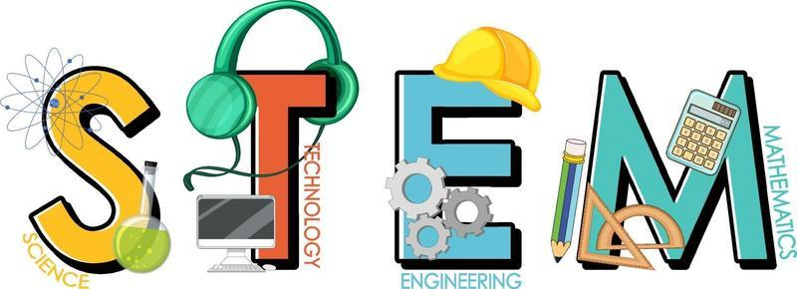  In STEM in Term Four the students will use Google Sheets to analyse and present data. They will design and modify an user interface for a digital system, and generate, communicate and evaluate the designs. Students will design and implement algorithms as visual programs involving multiple alternatives and learn how to program robots to use sensors.
VISUAL ARTS  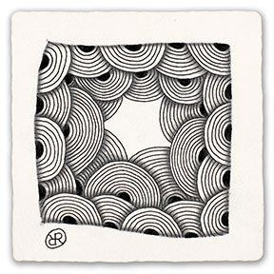  Ms Maegan Whiteley  In Term Four, Year Six students will explore personal expression and identity through drawing and mixed-media techniques. They will begin by studying contemporary artist Eni Oken, examining how she uses pattern, shading and detail to create intricate Zentangle artworks. Students will then design and refine their own Zentangle compositions, experimenting with line, repetition, contrast and texture to develop creativity and focus. They will explore the theme of place and perspective, learning how artists represent the environment and mood through their work. Using a creative mixed-media approach, students will trace their own photographs or sketches onto laminate sheets and add colour and pattern from behind using paint. Through this process, they will consider how composition, colour and layering can communicate a sense of space and personal connection to a place. | ITALIAN  Mrs Angela De Francesco    This term, students will explore materials and crafts through Italian. They will learn words for different materials like lana (wool), cotone (cotton), and carta riciclata (recycled paper), as well as festive vocabulary such as Natale (Christmas), regalo (gift), and decorazione (decoration).  Students will be practising describing materials in Italian (for example, È morbido, È naturale, È riciclato) and learning to work safely and responsibly with materials.

SOCIAL and EMOTIONAL LEARNING ( SEL )  In Term Four, our focus on Social-Emotional Learning (SEL) includes explicit lessons centred around the Positive Behaviour for Learning Matrix. These sessions are designed to empower students to master the specific behaviours outlined in our matrix. Through interactive activities and guided discussions, students will not only understand how these behaviours shape our learning environment but also recognise their role in shaping our collective identity as a school community. Guided by the overarching question,’How can understanding our emotions and working with others help us solve problems better?, we will explore key principles from the Resilience, Rights and Respectful Relationships curriculum. We will focus on strengthening our communication skills, managing our emotions, improving our problem-solving abilities, and learning how to confidently ask for help.  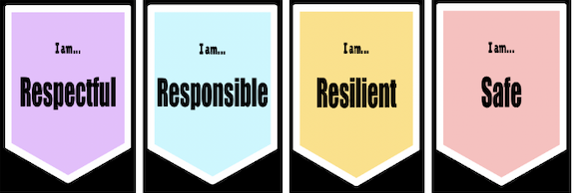  COMPELLING QUESTION: How can understanding our emotions and working with others help us solve problems better?  UNDERSTANDINGS:  - Recognising the influence of emotions on our behaviours help us to understand people's different reactions.  - Asking for help shows strength, not weakness and it shows you are willing to learn, work with others, and keep trying.  - There are different types of problems and some problems can be solved on your own, some with friends, and some need adult support.  - Communication is important, explaining your problem clearly helps others understand and support you.  - When others give help, listening and considering their ideas can make solutions more effective.  - There are many strategies for solving problems like breaking the problem into smaller steps, trying different solutions, staying calm, brainstorming or seeking advice.  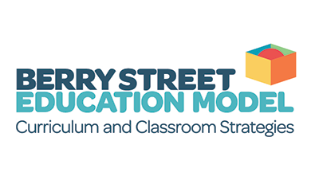 | TIMETABLES  Library Borrowing : Monday    Have you downloaded the Seesaw App onto your device to be informed about your child’s learning?  Please contact your child’s class teacher to gain access.
  STEM | Tuesday
  ITALIAN | Tuesday
  PHYSICAL EDUCATION | Thursday
  VISUAL ARTS | Thursday

