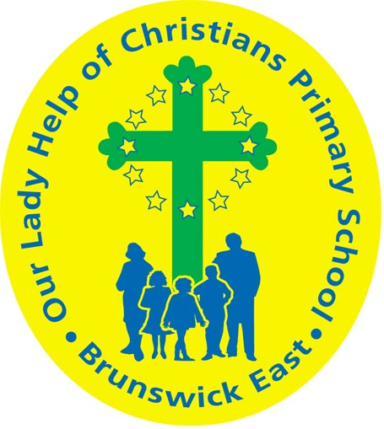
Our Lady Help Of Christians
Term 4 2025 Overview

Year Level: Prep Teachers: Emilie Owen & Megan Holmes
eowen@olbruswickeast.catholic.edu.au mholmes@olbruswickeast.catholic.edu.au
Over the term, the students will be working towards the learning outcomes and concepts outlined below.

RELIGIOUS EDUCATION  Christmas and Advent    This term the students will be developing their understanding of the story of Christmas and Jesus’ birth from Luke’s Infancy Narrative from the book of Luke 2: 1-20 (NRSV).  Students will be exploring the book of Luke, and how it portrays the birth and celebration of Jesus. They will demonstrate their learnings through retelling the story of Christmas. They will express their thoughts and feelings and make connections to their personal experiences.  Following the Advent liturgical season, students will explore the spiritual preparation across the four weeks leading up to Jesus’s birth, and the importance behind the signs and symbols of Advent including the wreath and the four candles representing hope, faith, joy and peace.    The students will respond to the parables and stories of Jesus through Godly play experiences where they can make connections and discover new insights and wonderings by asking questions.  Students will unpack the following questions;  - What happens at Christmas?  - How did Mary prepare?  - How do we prepare?  - What is the meaning of Christmas?  - Why is Christmas a special time in the Catholic tradition? | ENGLISH  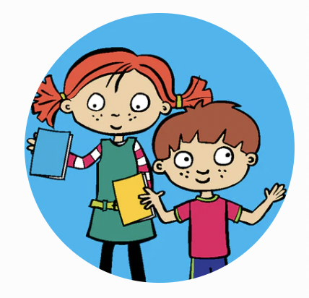  Our focus for reading and writing is continuing our Little Learners Love Literacy (LLLLs) program.  READING & VIEWING  The students will be:  - revising and consolidating Stages 1- 6 LLLL  - continuing to develop their understanding of common double consonants -(ff, ll, ss)  - using the suffix -s (for both third person verbs and plural nouns) and ed (for past tense verbs) in reading  - reading and spelling compound words and some two-syllable words  - reading and spelling words using consonant digraphs, such as- ck, sh, ch, th, ng, ph and wh  - continuing to make deeper connections through making inferences about how a character feels  - responding to literal and inferential comprehension questions when reading    - developing fluency and expression when reading.  WRITING  The students will be:  - continuing to build on their use of known letters and sounds to represent written language  - continuing to develop a bank of heart words that they can write from memory  - revising where to use punctuation in a sentence  - revising how to structure a simple and compound sentence  - continuing to build their understanding of how a narrative is written  - continuing to write factual sentences about a topic  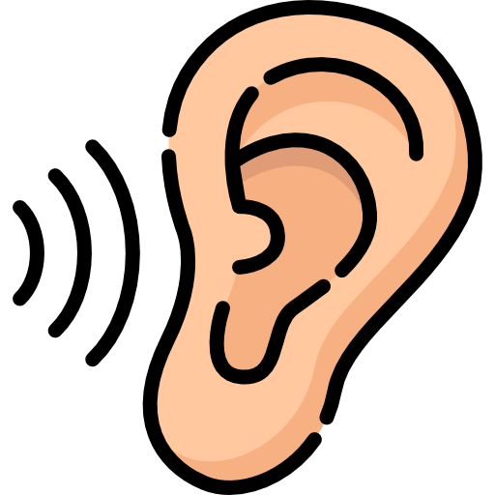  - beginning to proofread and edit their own writing.  SPEAKING & LISTENING  The students will be:  - continuing to contribute their ideas and opinions to whole class and small group discussions  - retelling a simple story using correct sequencing  - sharing their learning experiences by practising speaking in a loud, clear voice in front of an audience  - continuing to build their understanding of what a question is by asking and responding.
MATHEMATICS  NUMBER  The students will be:  - revising counting forwards and backwards to 20 from different starting points  - revising tens facts  - counting by tens  - identifying numbers that come before and after  - exploring ordinal numbers, such as first, second and third  - learning about money and exploring Australian coins, including identifying, matching and sorting.  MEASUREMENT  The students will be:    - using direct and indirect comparisons of time and explain reasoning in everyday language  - working on real world problems that involve applying direct comparisons of time, length, mass and capacity, to solve problems.  SPACE  The students will be:  - describing the position and location of themselves within a familiar space  - following a short sequence of instructions.  STATISTICS  The students will be:  - investigating data collection and simple graphs  - interpreting data by answering questions. | INQUIRY  COMPELLING QUESTION:  How can I be a problem solver?  This term, students will continue to develop their creative thinking through our design unit. Whilst exploring and following the design process, students will experience how specific designs can solve a problem. They will experiment with different materials to create their design, and use their reflective and analytical skills to refine elements of their designs as needed.  UNDERSTANDINGS:  - Design is all around us.  - Materials have many uses and are used for specific purposes.  - Designers follow a process to find a solution.  - Problems can be solved in different ways.  - Designers think and reflect when creating solutions to problems.  

PHYSICAL EDUCATION  Mr David Witchell  In Physical Education in Term Four, the students in Prep will continue to develop their ball skills, such as throwing, bouncing, dribbling and striking. They will also develop their skills of dribbling using both dominant and non - dominant hands. The students will also learn the basic skills of striking and use tennis racquets to hit a stationary and moving target  Students will also participate in the OLHC School Sports Day and incorporate skills they have learnt into the various activities.   | STEM  Science, Technology, Engineering & Mathematics  Mrs Joanna Hanson  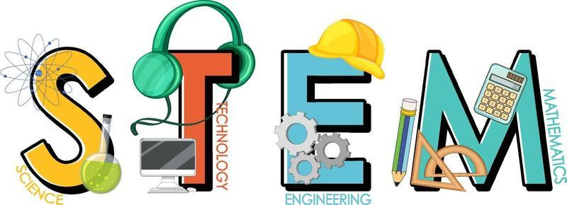  In STEM in Term Four, the students will identify hardware and software components in familiar digital systems. They will use a digital device (iPad, Bee-bot) for a specific purpose. Students will collect and represent simple data visually or digitally. They will then arrange the data to help make sense of it and look for patterns. The students will present data in different digital ways, such as using a table, a picture graph or a bar graph. The students will learn how to be safe online by logging in and out of shared devices and only sharing information with people they know.
VISUAL ARTS  Miss Maegan Whiteley    In Term Four, Prep students will explore creativity through texture, colour and shape. They will begin by experimenting with printing using different textures, such as bubble wrap, mesh, leaves and cardboard, creating colourful patterns. Students will engage with the story Ten Little Surfers, planning and decorating their own surfboards on paper before creating three dimensional PaperMagicClay surfboards and painting them with bright colours and patterns. They will also make ‘handprint animals’ and ‘shape monsters’, combining shapes, colours and patterns to create unique, expressive artworks. Through these activities, students will develop confidence in using line, colour, pattern and texture, producing works to display. | ITALIAN  Mrs Angela De Francesco  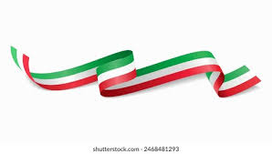  The students will be learning about everyday objects, materials, and how they are used in purposeful ways. Using Italian language, they will name common classroom and home objects, describe their features (e.g. soft, hard, rough, smooth). Through songs, storytelling, and hands-on mini-design challenges, students will use Italian language to talk about what things are made of (È di legno, è di plastica) and what they are used for.

SOCIAL and EMOTIONAL LEARNING ( SEL )  COMPELLING QUESTION:  How can I be an independent learner?    UNDERSTANDINGS:  This term the students will continue to engage in the Berry Street Education Model through developing their stamina for learning, creating a Ready to Learn Scale and a Ready to Learn Plan. They will identify different strategies that support their ability to learn and self regulate.  Students will also be encouraged to foster help-seeking behaviours as a way to improve their mental health and wellbeing. They will keep working with the Positive Behaviours for Learning Matrix, as well as the Inform and Empower program which helps them learn practical ways to stay safe online.  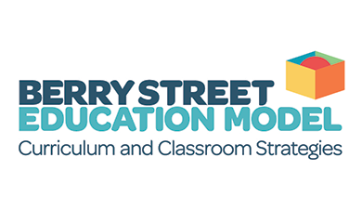 | TIMETABLES  Prep M  Prep E    Have you downloaded the Seesaw App onto your device to be informed about your child’s learning?  Please contact your child’s class teacher to gain access.
  STEM | Tuesday
  ITALIAN | Thursday
  PHYSICAL EDUCATION | Tuesday
  VISUAL ARTS | Thursday
  LIBRARY | Monday
  STEM | Tuesday
  ITALIAN | Thursday
  PHYSICAL EDUCATION | Tuesday
  VISUAL ARTS | Tuesday
  LIBRARY | Monday

