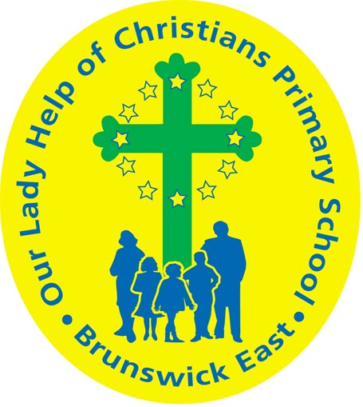
Our Lady Help Of Christians
Term Four 2025 Overview

Year Level: Three Teachers: Julie Tran 3J & Lara Keating 3K
jtran@olbruswickeast.catholic.edu.au lkeating@olbruswickeast.catholic.edu.au
Over the term, the students will be working towards the learning outcomes and concepts outlined below.

RELIGIOUS EDUCATION  ADVENT  The students will be exploring the season of Advent. They will consider the ways that Catholic people prepare for the birth of Jesus Christ at Christmas. Students will examine the contributions of historical figures from the Old Testament by exploring different stories of the Jesse Tree.  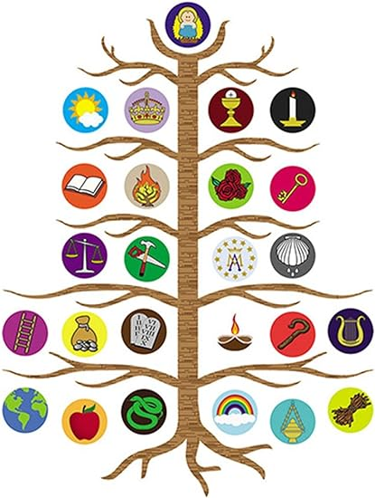  CHRISTMAS  Students will investigate Luke’s Infancy Narrative to consider:  - a historical perspective to make meaning of the symbols and rituals  - a contemporary perspective to recontextualise the messages to the modern context  - a forward-looking perspective so that we may ensure fulfil God’s dream for us and our community. | ENGLISH    READING & VIEWING  The students will be:  - continuing to build their comprehension skills to understand a variety of texts  - identifying the point of view of a text and suggesting alternative points of view  - discussing the effects of language devices used in poetry  - participating in Reciprocal Teaching reading groups, taking turns to lead roles of predictor, clarifier, questioner and summariser.  WRITING  The students will be:  - experimenting with poetic devices to write poems exploring own experiences and imagining  - developing their phonological knowledge through breaking words into syllables and sounds  - practising how to join diagonal and horizontal letters that are clearly formed and consistent in size.  SPEAKING & LISTENING  The students will be:  - interpreting ideas and information in spoken texts  - delivering short oral presentations, using appropriate voice levels, articulation, body language, gestures and eye contact  - developing skills of cooperation and problem solving when engaged in conversation.
MATHEMATICS  NUMBER  The students will be:  - representing money values and counting change required  - recalling and demonstrating proficiency with multiplication facts for 3, 4, 5 and 10  - extending and applying facts to develop the related division facts.  MEASUREMENT  The students will be:  - describing the relationship between the hours and minutes on analogue and digital clocks  - reading the time to the nearest minute  - interpreting and creating two-dimensional representations of familiar environments  - locating key landmarks and objects relative to each other  - measuring and comparing objects using familiar metric units of length, mass and capacity, and instruments with labelled markings.  SPACE  The students will be:  - making, comparing and classifying objects, identifying key features  - explaining why key features make them suited to their uses.  PROBABILITY  The students will be:  - identifying practical activities and everyday events that involve chance  - describing possible outcomes and events as ‘likely’, ‘unlikely’, ‘certain’ or ‘impossible’ and explaining with reasoning  - conducting repeated chance experiments and discussing the variation in outcomes. | INQUIRY  COMPELLING QUESTION: What can we design from raw materials?  This term students will be learning about design and technology. They will learn about how food and fibre (wheat and wool) are produced and how different materials are chosen for their purpose. Students will engage with the design process to make products using the materials of wool and wheat. They will visit the National Wool Museum in Geelong where they will participate in a tour and workshop, explaining the process of wool production from fleece to fibre.  UNDERSTANDINGS:  - Wheat and wool can be produced in different ways following a design process, including traditional hand methods or modern factory systems.  - The properties of materials affect how they are used.  - Food and fibre products are produced ethically and sustainably for different purposes.  - Different cultures use wheat and wool to sustain their living.  - Thinkers make connections between new ideas.  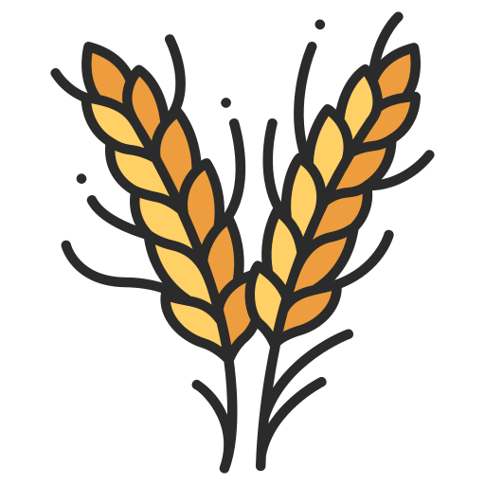  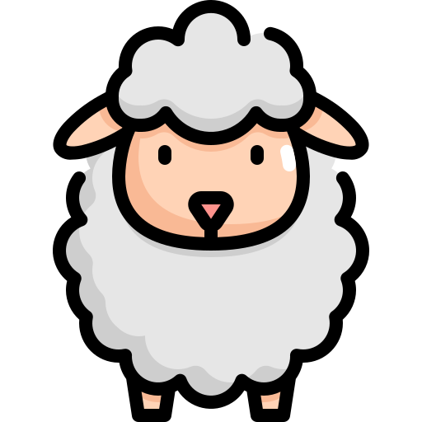

PHYSICAL EDUCATION  Mr David Witchell  During Term Four, the students in Year Three will focus on ball skills and will continue to develop their skills in small groups and modified games. They will participate in volleyball, soccer and hockey throughout the term. During these lessons they will continue to develop their throwing, passing, kicking and striking skills. The students will also gain a greater understanding of teamwork and the importance of it in small game situations.   | STEM  Science, Technology, Engineering & Mathematics  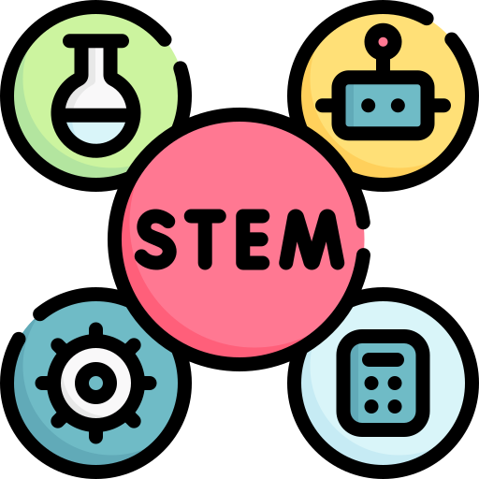  Mrs Joanna Hanson  In STEM in Term Four, students will create an interactive exhibit using the Micro:bit. They will create a list of success criteria for the exhibit, ask for feedback and use a digital document to track the results of the evaluation. Students will be introduced to the Lego Spike Kits, investigating ways of defining problems, brainstorming solutions and testing and refining prototypes. They will critically reflect on their work, identifying failure points and success criteria when comparing, modifying and evaluating a solution.
VISUAL ARTS  Miss Maegan Whiteley  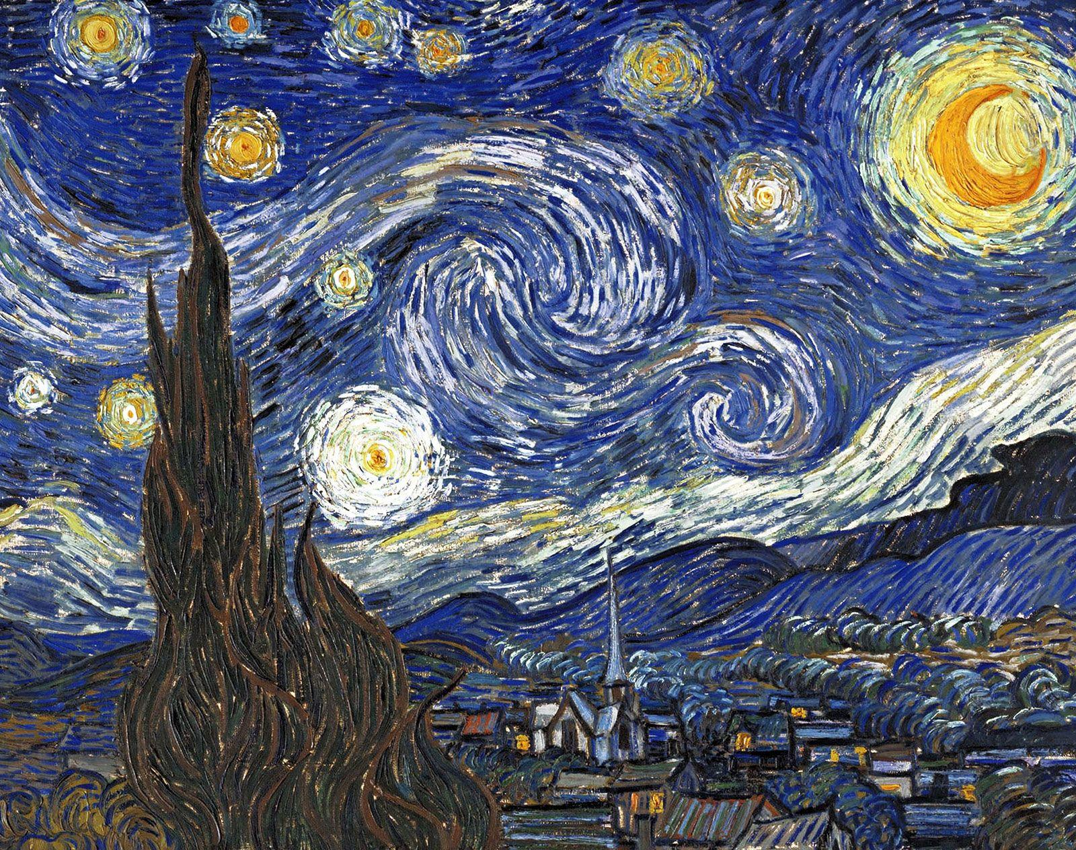  In Term Four, Year Three students will explore the colourful and expressive world of Pop Art. They will learn how artists like Andy Warhol used bright colours, repetition and everyday objects to create bold, eye-catching artworks. Students will design and create their own Pop Art pieces, experimenting with repeated images, contrasting colours and bold outlines. They will also investigate Vincent van Gogh, examining how he used line, brushstroke, texture and colour to convey mood and emotion in his landscapes. Students will practise short, directional strokes, layering of colour and expressive techniques to create depth, movement and feeling in their own artworks. | ITALIAN  Mrs Angela De Francesco    The students will explore the role of sheep in both Italian and Australian life, learning to use Italian vocabulary to describe farms, farmers, and sheep products, such as lana (wool), latte (milk), formaggio (cheese), and carne (meat). They will identify how sheep are farmed in each country and make cultural comparisons between Italian and Australian rural practices. Through songs, games, and short conversations, students will practise using simple Italian sentences to describe what sheep produce and the foods made from these products.  By the end of the unit, students will be able to name and describe sheep-related vocabulary in Italian and talk about common Italian products made from sheep.

SOCIAL and EMOTIONAL LEARNING ( SEL )  Positive Behaviour for Learning (PBL)  In Term Four, we are continuing to review our Positive Behaviour for Learning (PBL) expectations and practise the skills that support a safe, respectful, and responsible school environment. These sessions reinforce our school values and help students build consistency in their behaviour across all areas of the school.  SEL  In Term Four, the students will be learning that everyone feels stressed sometimes and that it is important to notice the signs of stress in ourselves and others. They will explore healthy ways to manage stress, such as using calming strategies and problem-solving skills. Students will also learn that asking for help is a sign of strength and that there are trusted people and resources they can turn to for support.  COMPELLING QUESTION: How can I recognise stress and seek help when I need it?  UNDERSTANDINGS:  - Everyone feels stressed or overwhelmed at times and this is a normal part of life.  - We can use calming and coping strategies to manage our emotions and feel more in control.  - Talking to trusted adults or friends can help us find solutions and feel supported.  - Learning when and how to ask for help builds resilience and confidence.  - Supporting others and practising empathy helps create a caring and safe community.  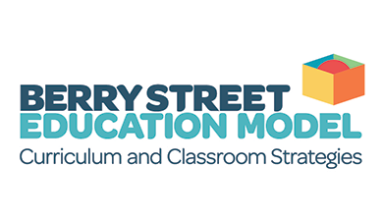 | TIMETABLES  Library Borrowing  3K: Monday  3J: Friday    Have you downloaded the Seesaw App onto your device to be informed about your child’s learning?  Please contact your child’s class teacher to gain access.
  STEM | Thursday
  ITALIAN | Wednesday
  PHYSICAL EDUCATION | Thursday
  VISUAL ARTS | Wednesday

