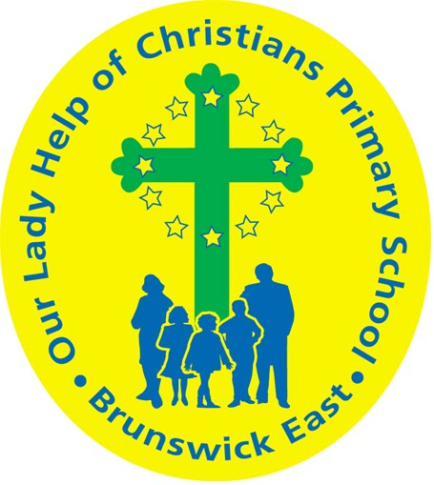
Our Lady Help Of Christians
Term Four 2025 Overview

Year Level: Two Teachers: Grace Dalla Zuanna 2 D
Teachers: Brigitte Callery ( Mon, Tues, Wed, Thurs) & Lisa Geary (Fri ) 2 C
bcallery@olbrunswickeast.catholic.edu.au gdallazuanna@olbrunswickeast.catholic.edu.au
lgeary@olbrunswickeast.catholic.edu.au
Over the term, the students will be working towards the learning outcomes and concepts outlined below.

RELIGIOUS EDUCATION  Religion in Term Four will be focussing on Mary, the mother of Jesus, as we journey toward Advent and Christmas. Students will be exploring the scripture stories of the Annunciation, the Visitation and Birth of Jesus with a particular focus on Mary who lived the first Advent. Students will reflect on and celebrate the four weeks of Advent and uncover the Christian meaning of Christmas - the birth of Jesus.  The students will be:  - listening, responding and retelling Luke’s account of the the birth of Jesus  - explaining and reflecting on the importance of Mary during Advent and Christmas  - identifying Advent as a time of waiting and preparation  - reflecting on the four weeks of Advent: Hope, Faith, Joy and Peace  - explaining the importance of the Catholic celebration of Christmas  - preparing for Christmas through song and prayer.  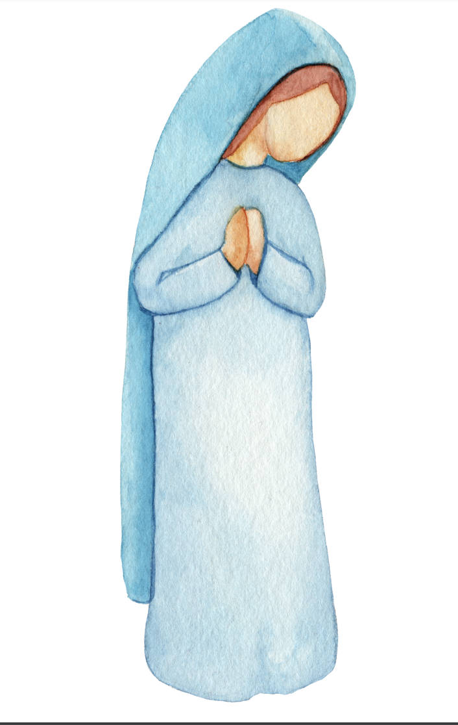 | ENGLISH  Throughout Term Four, our focus for reading is developing decoding skills using Little Learners Love Literacy , an evidence-based structured literacy program. Students will revise, practise and apply skills when reading, writing, speaking and listening.  READING & VIEWING  The students will be:  - revising phonological sounds taught  - understanding morphology – base words, adding prefixes and suffixes  - decoding unfamiliar words, including multi-syllable words and words with silent letters  - segmenting words for spelling and apply phoneme/grapheme knowledge  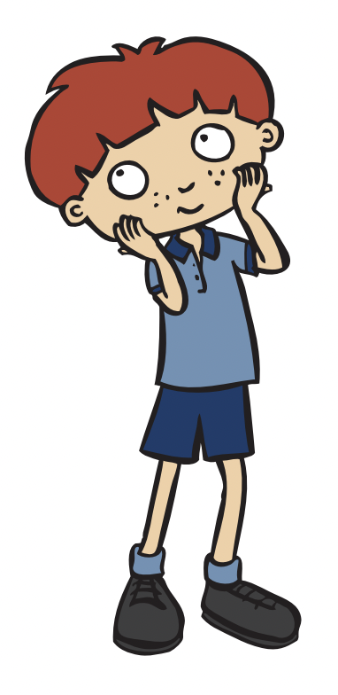  - developing their understanding of multi-syllabic words and compound words  - making text connections - What does this story remind you of?  - responding to literal and inferential comprehension questions.  WRITING  The students will be:  - exploring different forms of poetry  - experimenting with different poetic devices, such as similes, alliteration, senses and applying these to write poems  - exploring how persuasive texts are organised according to their purpose  - composing short persuasive texts using appropriate structure and technical vocabulary  - re-reading their own writing and discussing possible changes to improve meaning, spelling and punctuation.  SPEAKING & LISTENING  The students will be:  - delivering short spoken texts to the class  - actively listening to and extending the ideas of others  - applying learnt vocabulary and engaging with topics when sharing ideas with the class.
MATHEMATICS  NUMBER  The students will be:  - applying a range of calculation strategies to solve addition, subtraction and multiplicative worded problems.  MEASUREMENT  The students will be:  - identifying halves, quarters and eighths in relation to shapes, objects and events.  SPACE  The students will be:  - locating and moving positions by following directions and pathways.  STATISTICS  The students will be:  - collecting and sorting data into relevant categories  - creating different graphical representations of data  - comparing, describing and responding to questions about the features of data collected.  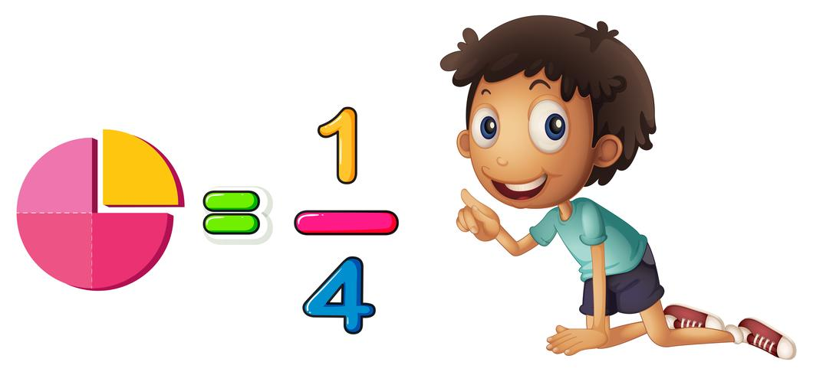 | INQUIRY  COMPELLING QUESTION: What does it sound like?  This term, students will combine design and physical science to learn about the sounds produced by different materials. Students will explore how sounds can vary according to pitch and volume and through the combination of different materials. They will become designers and follow the design process to produce an object which makes a sound.  UNDERSTANDINGS:  - Movement can make materials vibrate to make other sounds.  - Different actions can be used to produce and vary pitch and volume.  - Combining different materials can create different sounds.  - Designers experiment with different materials to make different sounds.  - Designers follow a design brief to create a product.  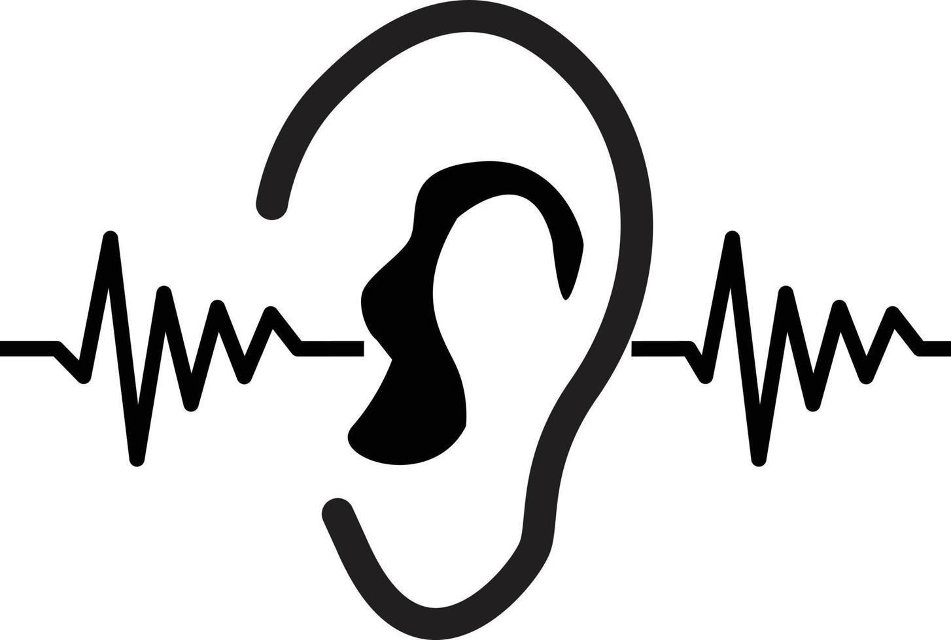

PHYSICAL EDUCATION  Mr David Witchell  In Physical Education in Term Four, the students in Year Two will continue to develop their ball skills, such as throwing, catching, striking and kicking.  Students will participate in small games and modified activities to improve these skills.  During Term Four, the students will be participating in team sports, such as hockey, soccer and tennis. A focus will also be on striking a stationary and non stationary target. The students will participate in the OLHC School Sports day and have an opportunity to demonstrate some of the skills that they have learnt in Physical Education lessons.   | STEM  Science, Technology, Engineering & Mathematics  Mrs Joanna Hanson  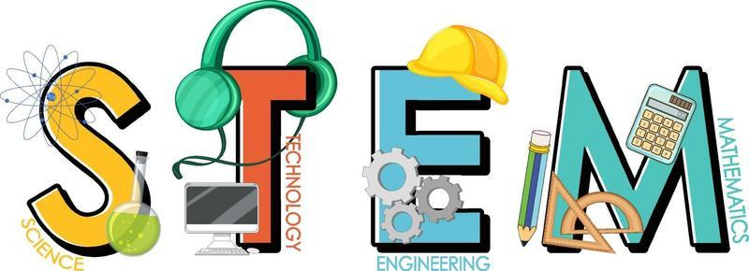  In STEM in Term Four, the students will be investigating digital systems. They will explore how different hardware connects and follows commands. Students will learn about capturing data, such as photographs, on iPads and transferring this data to different locations or Apps within the iPad. They will learn how to download images and insert them into a document. Students will collaborate to create a digital book, where they will be responsible for creating, uploading and sharing content and organising the ideas with their peers. They will learn to make decisions when using images and video, ensuring information shared is safe and respectful.
VISUAL ARTS  Miss Maegan Whiteley  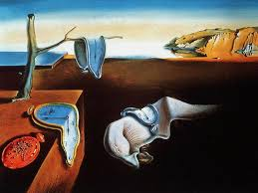  In Term Four, Year Two students will explore the colourful and playful world of Australian birds, inspired by artist Pete Cromer. They will learn how Cromer uses bright colours, bold lines and fun patterns to bring birds to life. Students will experiment with sketching, patterning and oil pastel techniques to create their own vibrant bird drawings. Students will also investigate the imaginative world of Salvador Dalí, exploring how he painted dream-like scenes and unusual objects, such as melting clocks. They will practise drawing and distorting shapes, then use markers and acrylic paint to create their own clocks. Students will fold and drape their clocks over tables or benches to bring the surreal quality of Dalí’s work to life. | ITALIAN  Mrs Angela De Francesco  The students will learn to name and recognise a variety of musical instruments in Italian. They will explore how different instruments make sounds that can be forte (loud), piano (soft), alto (high) or basso (low). Through listening activities and class investigations, students will observe and describe the sounds they hear using simple Italian words and phrases. They will also participate in Italian songs and games that involve playing or identifying instruments. This unit will help students build their vocabulary, listening skills, and confidence in speaking Italian in a fun, musical context.

SOCIAL and EMOTIONAL LEARNING ( SEL )  COMPELLING QUESTION: What can I do when I’ve got a problem?  UNDERSTANDINGS:  - Recognise that there are many ways to solve conflict.  - Recognise ways their opinions are similar to, or differ from, the views of people around them.  - Identify cooperative behaviours in a range of group activities.  - Practise individual and group decision-making.  - Practise solving simple interpersonal problems.  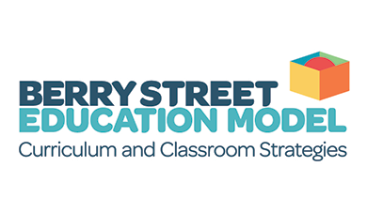 | TIMETABLES  Library Borrowing - Friday    Have you downloaded the Seesaw App onto your device to be informed about your child’s learning?  Please contact your child’s class teacher to gain access.
  STEM | Wednesday 2C  Thursday 2D
  ITALIAN | Wednesday 2C  Tuesday 2D
  PHYSICAL EDUCATION | Tuesday 2C  Wednesday 2D
  VISUAL ARTS | Tuesday 2C  Wednesday 2D

