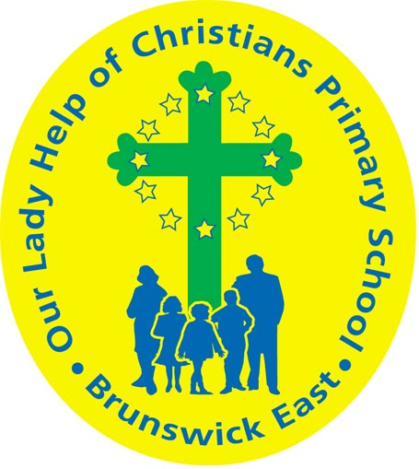
Our Lady Help Of Christians
Term Four 2025 Overview

Year Level: One Teachers: Renee Bouvier 1 B
Karina De Giusti (Mon & Tues) & Dani Criscione (Wed - Fri) 1DK
rbouvier@olbruswickeast.catholic.edu.au
kdegiusti@olbruswickeast.catholic.edu.au & dcriscione@olbruswickeast.catholic.edu.au
Over the term, the students will be working towards the learning outcomes and concepts outlined below.

RELIGIOUS EDUCATION  Religion in Term Four will be focussing on Mary, the mother of Jesus, as we journey toward Advent and Christmas. Students will be exploring the scripture stories of the Annunciation, the Visitation and Birth of Jesus with a particular focus on Mary who lived the first Advent. Students will reflect on and celebrate the four weeks of Advent and uncover the Christian meaning of Christmas - the birth of Jesus.  The students will be:  - listening, responding and retelling Luke’s account of the the birth of Jesus  - explaining and reflecting on the importance of Mary during Advent and Christmas  - identifying Advent as a time of waiting and preparation  - reflecting on the four weeks of Advent: Hope, Faith, Joy and Peace  - explaining the importance of the Catholic celebration of Christmas  - preparing for Christmas through song and prayer.  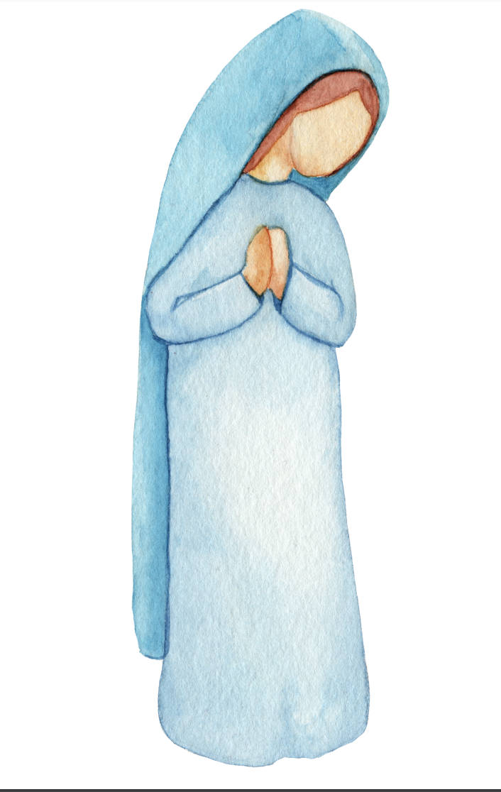 | ENGLISH  READING & VIEWING  The students will be:  - comparing how images and sound in different types of texts contribute to meaning  - ​​listening to, reciting and discussing poems, chants, rhymes and songs  - imitating and inventing sound patterns, including alliteration and rhyme  - using knowledge of short vowels, common long vowels, consonant blends and digraphs, to read and write one and two syllable words.  WRITING  The students will be:  - exploring how explanation and procedural texts are organised according to their purpose  - composing short explanation and procedural texts using appropriate structure and technical vocabulary  - re-reading their own writing and discussing possible changes to improve meaning, spelling and punctuation.  SPEAKING & LISTENING  The students will be:  - delivering short spoken texts to an audience  - exploring how language, facial expressions and gestures are used to interact with others when asking for and providing information, requesting and giving commands.  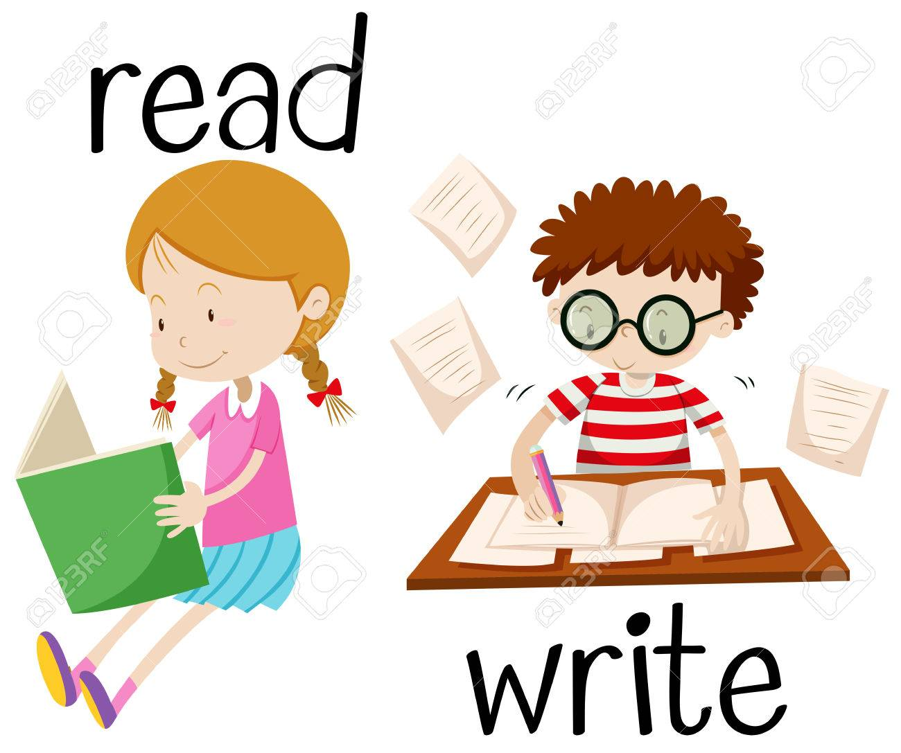
MATHEMATICS  NUMBER  The students will be:  - solving addition and subtraction problems within 20  - partitioning two-digit numbers in different ways and writing addition equations.  MEASUREMENT  The students will be:  - describing the duration and sequence of events using years, months, weeks, days and hours  - telling time to the hour on an analogue clock.  SPACE  The students will be:  - giving and following directions to move people and objects to different locations within a space  - identifying and making regular and irregular two-dimensional shapes  - identifying and describing three-dimensional objects  - making, comparing and classifying familiar shapes  - recognising familiar shapes and objects in the environment  - identifying the similarities and differences between familiar shapes.  STATISTICS  The students will be:  - collecting data by observation and conducting surveys.   | INQUIRY  COMPELLING QUESTION: What does it sound like?  This term, students will combine design and physical science to learn about the sounds produced by different materials. Students will explore how sounds can vary according to pitch and volume and through the combination of different materials. They will become designers and follow the design process to produce an object which makes a sound.  UNDERSTANDINGS:  - Movement can make materials vibrate to make other sounds.  - Different actions can be used to produce and vary pitch and volume.  - Combining different materials can create different sounds.  - Designers experiment with different materials to make different sounds.  - Designers follow a design brief to create a product.  

PHYSICAL EDUCATION  Mr David Witchell  In Physical Education in Term Four the students in Year One will continue to focus on ball skills, such as throwing, catching, bouncing and striking. Students will continue to develop their skills through small games and modified activities.  The students in Year One will participate in team sports, such as tennis and soccer. They will also focus on hitting a stationary and a moving target.  Students will also participate in the OLHC School Sports Day where they will be able to use their skills that they have learnt during lessons.   | STEM  Science, Technology, Engineering & Mathematics  Mrs Joanna Hanson    In STEM in Term Four, the students will be investigating digital systems. They will explore how different hardware connects and follows commands. Students will learn about capturing data, such as photographs, on iPads and transferring this data to different locations or Apps within the iPad. They will learn how to download images and insert them into a document. Students will collaborate to create a digital book, where they will be responsible for creating, uploading and sharing content and organising the ideas with their peers. They will learn to make decisions when using images and video, ensuring information shared is safe and respectful.
VISUAL ARTS  Ms Maegan Whiteley  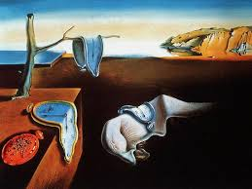  In Term Four, Year One students will explore the colourful and playful world of Australian birds, inspired by artist Pete Cromer. They will learn how Cromer uses bright colours, bold lines and fun patterns to bring birds to life. Students will experiment with sketching, patterning and oil pastel techniques to create their own vibrant bird drawings. They will also investigate the imaginative world of Salvador Dalí, exploring how he painted dream-like scenes and unusual objects, such as melting clocks. They will practise drawing and distorting shapes, then use markers and acrylic paint to create their own clocks. Students will fold and drape their clocks over tables or benches to bring the surreal quality of Dalí’s work to life. | ITALIAN  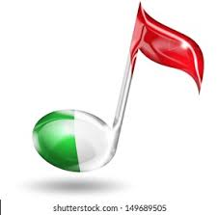  Mrs Angela De Francesco  The students will learn to name and recognise a variety of musical instruments in Italian. They will explore how different instruments make sounds that can be forte loud, piano soft, alto high or basso low. Through listening activities and class investigations, students will observe and describe the sounds they hear using simple Italian words and phrases. They will also participate in Italian songs and games that involve playing or identifying instruments. This unit will help students build their vocabulary, listening skills, and confidence in speaking Italian in a fun, musical context.

SOCIAL and EMOTIONAL LEARNING ( SEL )  COMPELLING QUESTION: What can I do when I’ve got a problem?  UNDERSTANDINGS:  - Recognise that there are many ways to solve conflict.  - Recognise ways their opinions are similar to, or differ from, the views of people around them.  - Identify cooperative behaviours in a range of group activities.  - Practise individual and group decision-making.  - Practise solving simple interpersonal problems.  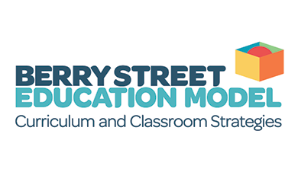 | TIMETABLES  Library Borrowing Friday    Have you downloaded the Seesaw App onto your device to be informed about your child’s learning?  Please contact your child’s class teacher to gain access.
  STEM | 1DK Tuesday  1B Wednesday
  ITALIAN | 1DK Wednesday  1B Thursday
  PHYSICAL EDUCATION | 1B Wednesday  1DK Thursday
  VISUAL ARTS | 1DK Wednesday  1B Thursday

