**Our Lady Help Of Christians**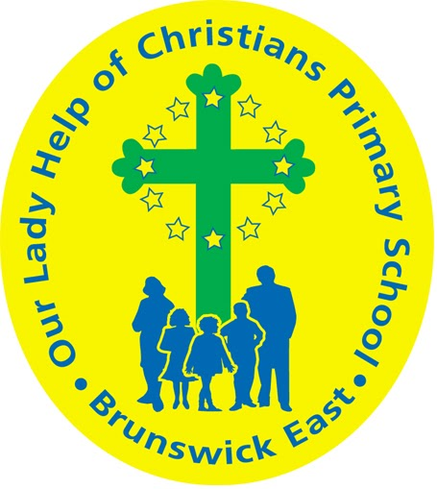

**Term One 2025 Overview**

Year Level: Three Teachers: Julie Tran 3J & Lara Keating 3K

jtran@olbruswickeast.catholic.edu.au lkeating@olbruswickeast.catholic.edu.au

Over the term, the students will be working towards the learning outcomes and concepts outlined below.

| **RELIGIOUS EDUCATION**  Students will learn about prayer and how it strengthens their relationship with God. They will explore why Jesus taught the importance of prayer and reflect on their own prayer experiences. Students will also learn about the meaning of symbols, rituals, and sacred elements in prayer, as well as different personal and school prayer practices.    Students will also learn about the connection between God, Jesus, and the Holy Spirit as described in the New Testament. Through the story of Jesus' life, death, and resurrection, they will explore God's loving forgiveness. Additionally, students will learn about God's presence in the world and the three key parts of Lent: prayer, fasting, and giving to others. | **ENGLISH**  READING & VIEWING  The students will be:   * using reading material to prepare for NAPLAN * using comprehension strategies, such as predicting making connections, sequencing information and identifying between fact and opinion * identifying the features of different text types * locating information in a text * continuing to develop reading fluency.   WRITING  The students will be:   * developing an understanding of the structure and features of persuasive and narrative texts * planning, drafting and editing narrative and persuasive texts in preparation for NAPLAN * developing their phonological knowledge through breaking words into syllables and sounds * practising how to join letters that are clearly formed and consistent in size.   SPEAKING & LISTENING  The students will be:   * interpreting ideas and information in spoken texts * planning and delivering short presentations * developing skills of cooperation when engaged in conversation. |
| --- | --- |
| **MATHEMATICS**  NUMBER  The students will be:   * identifying and categorising numbers as odd or even * recognising, representing and ordering numbers beyond 10 000 * solving problems involving estimation to enhance mathematical reasoning.   ALGEBRA  The students will be:   * recognising and explaining the connection between addition and subtraction as inverse operations * applying knowledge of addition and subtraction facts to 20 to develop efficient mental and written strategies * recalling and using multiplication facts for 3, 4, 5 and 10 * multiplying and dividing one- and two-digit numbers, representing problems using a variety of strategies.   MEASUREMENT  The students will be:   * recognising and using days, hours, minutes and seconds to estimate and compare event durations * describing the relationship between the hours and minutes on analog and digital clocks * reading the time to the nearest minute. | **INQUIRY**  COMPELLING QUESTION:  Who makes decisions in our community and how are they made?  Students will explore how Australia is a democratic nation where citizens elect leaders to make important decisions. They will learn about the role of local government in keeping communities safe and running smoothly. Students will also investigate the importance of rules and laws in maintaining order and fairness. Additionally, they will explore how individuals can contribute to their communities by identifying needs, solving problems, and making positive changes.  UNDERSTANDINGS:   * Australia is a democratic nation where citizens elect people to make decisions. * Local governments are elected to make decisions to keep our communities functioning and safe. * Within a community there are rules and laws that keep law and order. * Citizens contribute to their communities by identifying needs and solving problems to create positive change. |

| **PHYSICAL EDUCATION**  **Mr David Witchell**    In Physical Education classes this term, the students will continue to develop basic skills, such as overarm throwing, striking and catching through small activities and modified games. The students will also begin focussing on Athletics in Term One and will participate in running, jumping and throwing activities. These skills will be developed in preparation for the District Trials in Term Two. | **STEM**  **Science, Technology, Engineering & Mathematics**  **Mrs Joanna Hanson**    In STEM in Term One, the students will explore forces such as gravity, tension and compression by investigating the effect of these forces on the behaviour of objects. They will identify and explore properties and relationships of engineered structures, by constructing and testing cardboard chairs and spaghetti bridges. Students will investigate materials, tools and equipment to discover characteristics and properties. They will explore architecture and compare how buildings were constructed in the past and present, taking note of engineering innovations. The students will be introduced to Tinkercad and work collaboratively to generate, develop and communicate design ideas using this platform. Students will develop their skills in negotiation and planning effectively as a team. |
| --- | --- |
| **VISUAL ARTS**  **Mrs Maegan Whiteley**    In Term One of Visual Art, Year Three students will explore optical illusions and reflections through Yayoi Kusama’s use of dots, symmetry, and repetition. They will create individual and group artworks, including symmetrical dot patterns and ‘mini infinity boxes’, while experimenting with reflections. Students will also learn about the cultural significance of pom-poms in Latin American art, designing their own colourful pom-poms inspired by Peruvian and Mexican textiles. This term will foster creativity, pattern-making, and cultural exploration through hands-on projects and collaborative activities. | **ITALIAN**  **Mrs Angela De Francesco**    Students will learn and use the Italian language to engage in various games. They will acquire phrases for inviting others to play, taking turns, and asking and answering questions. Additionally, they will revisit their knowledge of numbers and apply it during gameplay. Through exposure to various texts, they will explore game rules and the language needed for participation. |

| **SOCIAL and EMOTIONAL LEARNING ( SEL )**  COMPELLING QUESTION:  What role do personal values play in shaping identity and community?  This term our focus on Social-Emotional Learning (SEL) includes explicit lessons centred around the Positive Behaviour for Learning (PBL) Matrix. These sessions aim to empower students to master specific behaviours, shaping our school community identity.  UNDERSTANDINGS:   * Knowing your values helps you understand your identity. * Values can help us to connect with each other and the community in meaningful ways. * To build relationships within our communities, we share and acknowledge our strengths. | **TIMETABLES**  Library Borrowing  3J Friday  3K Monday   | STEM | 3J & 3K Thursday | | --- | --- | | ITALIAN | 3J & 3K Wednesday | | PHYSICAL EDUCATION | 3J & 3K Thursday | | VISUAL ARTS | 3J & 3K Wednesday |     Have you downloaded the Seesaw App onto your device to be informed about your child’s learning?  Please contact your child’s class teacher to gain access. |
| --- | --- | --- | --- | --- | --- | --- | --- | --- | --- |