**Our Lady Help Of Christians**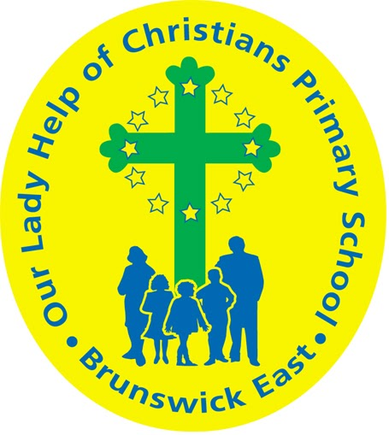

**Term 2 2025 Overview**

Year Level: Prep Teachers: Emilie Owen & Megan Holmes

eowen@olbruswickeast.catholic.edu.au mholmes@olbruswickeast.catholic.edu.au

Over the term, the students will be working towards the learning outcomes and concepts outlined below.

| **RELIGIOUS EDUCATION**  CREATION  This term the students will be building their understanding of what it means to be a good steward and how they can care for God’s creations.  Students will respond to the creation story through Godly Play experiences where they will make connections and discover new insights and wonderings by asking questions.  Students will understand that:   * Catholics believe that God created the world * God is a creator * the creation scripture tells the story of how God created the world * we have a responsibility to be stewards of creation * we need to appreciate the world around us * actions can make a difference.   Students will continue to engage in prayerful experiences, such as morning and afternoon prayer. They will practise making the Sign of the Cross and continue to build their understanding of the importance of being respectful and reverent during these prayerful experiences. | **ENGLISH**  **READING & VIEWING**  The students will be:   * recognising letter names and spoken sounds * breaking words apart into sounds and blending back together to read them, such as c-a-t = cat * displaying reading behaviours, such as correctly holding a book, pointing to the words and discussing the pictures * exploring how the combination of text and images creates meaning * engaging in Little Learners Love Literacy decodable texts by responding to literal and inferential questions * developing their ability to correctly-sequence and discuss a narrative text * making inferences about a character’s feelings.   **WRITING**  The students will be:   * developing their awareness of directionality when writing e.g. from left to right, top to bottom * constructing sentences which are appropriately finger-spaced apart * using capital letters at the beginning of sentences, and when writing proper nouns * strengthening letter formation of lowercase and capital letters * using known letters to represent the sounds they can hear in words * using beginning concepts of sound-letter correspondence, punctuation, text and word knowledge to create short- texts.   **SPEAKING & LISTENING**  The students will be:   * using spoken language to support decoding and blending of sounds/words * recognising we can use speech to gesture, write and communicate our thoughts and feelings * engaging in speaking and listening experiences to develop their vocabulary. |
| --- | --- |
| **MATHEMATICS**  NUMBER  The students will be:   * representing part-part-whole relationships in numbers up to 10 using materials * recognise and name the number of objects within a collection up to five using subitising * recognising numbers represented in ten-frames * reading a recognising numbers 0-20 * counting forwards, backwards using numbers 0-20 * counting and comparing collections to at least 20 using counting and explaining their reasoning.   SPACE  The students will be:   * naming familiar shapes * identifying and describing familiar shapes within objects in the environment * sorting shapes into groups based on different features, such as the number of sides, colour or size, and describing how they have been sorted * creating pictures using familiar shapes. | **INQUIRY**  COMPELLING QUESTION: Why is it important to look after plants and animals?  Throughout Term Two, students will develop their understanding of what plants and animals need in order to grow and be healthy. They will explore the different physical and behavioural characteristics of animals and what they need to survive and thrive.  UNDERSTANDINGS:   * Animals and plants that live on farms have basic needs. * Animals have different physical and behavioural characteristics. * Plants have observable features that can be used to group them in different ways. * Researchers formulate questions to find out information. |

| **PHYSICAL EDUCATION**  **Mr David Witchell**  Throughout Term Two, the students in Prep will continue to develop their basic motor skills such as running, throwing, catching and bouncing. They will develop these skills through partner and small group activities. The students will also learn the correct technique for overarm throwing and will be able to use these skills in game situations. Students will also begin to learn new skills in Australian Rule Football and basketball. | **STEM**  **Science, Technology, Engineering & Mathematics**  **Mrs Joanna Hanson**    In STEM in Term Two, students will explore how materials can be combined in a variety of ways. They will plan and conduct experiments to test the properties of materials, including observing the waterproof properties of materials. They will develop their skills of observing, describing, comparing and communicating. Using the data collected in the experiments, the students will develop a prototype of an outdoor, weatherproof object. They will develop their communication skills to explain their reasoning throughout the unit. |
| --- | --- |
| **VISUAL ARTS**  **Mrs Maegan Whiteley**    In Term Two of Visual Art, Prep students will explore colours and patterns in The Rainbow Fish to inspire their own designs of colourful, patterned fish drawings. They will explore how to create painted rock bugs, where they will practice attention to detail and the use of their fine motor skills by designing and painting unique insects on smooth rocks. Building on their exploration of nature, students will also engage in leaf printing, creating textured prints that highlight the beauty of different leaf shapes. Finally, students will create a colourful flower collage, using a variety of materials and drawing inspiration from the famous artworks of Henri Matisse. | **ITALIAN**  **Mrs Angela De Francesco**    Students will learn how to make the Sign of the Cross in Italian.  They will also focus on learning the numbers from one to ten, and will engage in a variety of songs, chants, and games to reinforce their understanding. Additionally, students will revisit the greetings introduced in Term One to help retain and strengthen their knowledge in this area. |



| **SOCIAL and EMOTIONAL LEARNING**  **( SEL )**  In Term Two, our focus on Social-Emotional Learning (SEL) includes explicit lessons centred around the Positive Behaviour for Learning Matrix.  These sessions are designed to empower students to master the specific behaviours outlined in our matrix. Through interactive activities and guided discussions, students will not only understand how these behaviours shape our learning environment but also recognise their role in shaping our collective identity as a school community. Anchored by the overarching question, "How do our behaviours shape our learning environment?", these sessions will facilitate a deeper understanding of the positive behaviours expected at OLHC, fostering a shared understanding among students. By engaging in this structured exploration, students will develop the skills and awareness needed to contribute to a positive and conducive learning environment at Our Lady Help of Christians.  COMPELLING QUESTION: How can I use my personal strengths to be a better learner?  UNDERSTANDINGS  We all have personal strengths and challenges.  Setting personal goals helps us to be better learners.  Having a growth mindset helps us to achieve our goals. | **TIMETABLES**  Library Borrowing - Monday  **Prep M**   | STEM | Tuesday | | --- | --- | | ITALIAN | Thursday | | PHYSICAL EDUCATION | Tuesday | | VISUAL ARTS | Thursday | | LIBRARY | Monday |   **Prep E**   | STEM | Tuesday | | --- | --- | | ITALIAN | Thursday | | PHYSICAL EDUCATION | Tuesday | | VISUAL ARTS | Tuesday | | LIBRARY | Monday |     Have you downloaded the Seesaw App onto your device to be informed about your child’s learning?  Please contact your child’s class teacher to gain access. |
| --- | --- | --- | --- | --- | --- | --- | --- | --- | --- | --- | --- | --- | --- | --- | --- | --- | --- | --- | --- | --- | --- |