**Our Lady Help Of Christians**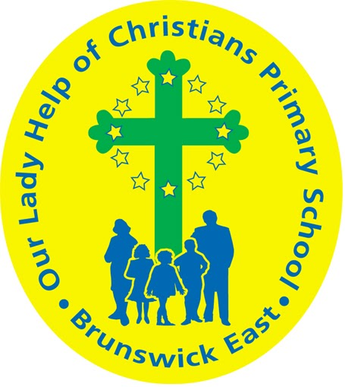

**Term Two 2025 Overview**

Year Level: One Teachers: Renee Bouvier 1B

Karina De Giusti ( Mon & Tues) & Dani Criscione ( Wed- Fri ) 1DK

rbouvier@olbruswickeast.catholic.edu.au

[kdegiusti@olbruswickeast.catholic.edu.au](mailto:kdegiusti@olbruswickeast.catholic.edu.au) & dcriscione@olbruswickeast.catholic.edu.au

Over the term, the students will be working towards the learning outcomes and concepts outlined below.

| **RELIGIOUS EDUCATION**  During Religion this term the students will be exploring the story of creation according to the Catholic tradition as well as the Indigenous Dreamtime stories. They will engage in artistic expression and meditation to deepen their understanding. Students will be reflecting on how to become responsible stewards of the world around them.  The students will be:   * reflecting on the creation story through art and meditation * unpacking the significance of each day of the creation story * making connections between the Christian Creation story and Indigenous Dreamtime stories * writing prayers for creation. | **ENGLISH**  Our focus for reading and writing is continuing our Little Learners Love Literacy (LLLLs) program.  **READING & VIEWING**  The students will be:   * developing segmenting skills, being able to adjust reading tone while reading * practising graphemes and phonemes and identifying them correctly in unknown words * engaging in Little Learners Love Literacy decodable texts by responding to literal and inferential questions * recognising and reading a selection of high frequency words * developing their reading stamina by engaging in ‘read to self’ * reading texts at their level with fluency and self-correcting when mistakes are made.   **WRITING**  The students will be:   * exploring recounts and informative texts * using features of the text type, for example an introduction, paragraphs and conclusion * understanding and applying Colourful Semantics approach (who, what doing, what & where) to a sentence * rereading their writing to check for errors, such as correct use of capital letters, full stops and question marks.   **SPEAKING & LISTENING**  The students will be:   * making short presentations, speaking clearly * asking questions as a researcher to gain information * segmenting words orally into sounds, for example s/t/u/ff * practising listening skills, such as showing interest, taking turns and recognising the contributions of others. |
| --- | --- |
| **MATHEMATICS**  In Mathematics during Term Two students will be learning different addition and subtraction strategies. Students will be further developing their mental computation skills, while developing new strategies to use. They will learn strategies on how to approach complex questions, and how numbers can be organised and used for representation.  NUMBER  The students will be:   * recognising, modelling, reading, writing and ordering numbers to at least 120 * solving simple addition and subtraction problems using a range of strategies * locating numbers on a numberline.     MEASUREMENT  The students will be:   * comparing and ordering objects and events using attributes of length, mass and capacity explaining their reasoning * measuring the length of shapes and objects using informal units, recognising that units need to be uniform and used end-to-end * describing the duration and sequence of events using years, months, weeks, days and hours. | **INQUIRY**  Throughout Term Two, students will be exploring the different ways animals and plants are classified according to physical features, habitats, life cycles and environmental adaptations.  COMPELLING QUESTION: *How can we classify living things?*  UNDERSTANDINGS:   * Plants and animals have observable features that can be used to classify them. * Animals have external physical features which perform different functions for survival. * Animals live in different habitats and rely on certain plants to survive. * Seasonal changes influence the behaviours of plants and animals. * Animals produce offspring through eggs or live birth. * Researchers gather and organise information in a clear way. |

| **PHYSICAL EDUCATION**  **Mr David Witchell**    In Term Two the students will continue to improve their skills of throwing, catching, bouncing and dribbling. They will perform these skills in small groups and game situations. The students in Year One will also focus on skills used in Australian Rules Football and basketball, such as kicking, marking, dribbling and passing. They will also participate in a number of fitness activities to understand the importance of being active. | **STEM**  **Science, Technology, Engineering & Mathematics**  **Mrs Joanna Hanson**    In STEM in Term Two, students will explore how materials can be mixed together to make new products. The students will compare the properties of cooked and uncooked food, predict how heating and cooling can change foods and learn about how changes to food can be either reversible or non reversible. They will develop their communication skills by creating annotated drawings and data tables to represent and explain their understanding of how materials can be physically changed. |
| --- | --- |
| **VISUAL ARTS**  **Mrs Maegan Whiteley**    In Term Two of Visual Arts, Year One students will explore the vibrant and dynamic work of David Hockney, focusing on his use of bright colours and bold shapes in landscapes and backyard scenes. Students will create their own colourful landscapes using oil pastels and watercolour paints. They will also delve into the playful world of Keith Haring’s ‘dancing dogs’, learning how to use simple shapes and bold lines to create fun and energetic figures. Students will plan and explore how using colour and shape can bring life to their art pieces. | **ITALIAN**  **Mrs Angela De Francesco**    Students will learn the names of common animals in Italian and practice responding to simple questions such as Che animale è? ("What animal is it?"). They will begin to read and write basic animal-related words in Italian. Through songs, games, and stories featuring animals, students will make connections to animals they are already familiar with in English. |

| **SOCIAL and EMOTIONAL LEARNING ( SEL )**  In Term Two, our Social-Emotional Learning (SEL) program will centre on revision lessons aligned with the *Positive Behaviour for Learning*. These sessions are designed to support students in mastering the specific positive behaviours identified in our matrix.  By actively participating in these sessions, students will deepen their understanding of expected behaviours at Our Lady Help of Christians and strengthen the skills needed to foster a positive, supportive, and cohesive school culture.  COMPELLING QUESTION: *How can I use my strengths to set goals?*  UNDERSTANDINGS:   * Knowing our character strengths helps us to set goals. * We all have different character strengths. * Strengths help us to be successful. * A growth mindset helps me to develop other strengths. | **TIMETABLES**  Library Borrowing Friday   | STEM | 1DK Tuesday  1B Wednesday | | --- | --- | | ITALIAN | 1DK Wednesday  1B Thursday | | PHYSICAL EDUCATION | 1B Wednesday  1DK Thursday | | VISUAL ARTS | 1DK Wednesday  1B Thursday |     Have you downloaded the Seesaw App onto your device to be informed about your child’s learning?  Please contact your child’s class teacher to gain access. |
| --- | --- | --- | --- | --- | --- | --- | --- | --- | --- |