**Our Lady Help Of Christians**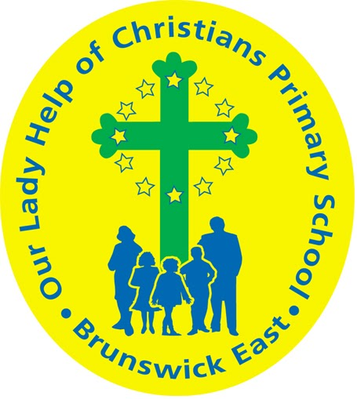

**Term One 2025 Overview**

Year Level: Six Teachers: Mary Papworth 6P mpapworth@olbruswickeast.catholic.edu.au

Nyree Clyne 6C Mon - Thurs nclyne@olbruswickeast.catholic.edu.au

Damien Murray 6C Fri dmurray@olbruswickeast.catholic.edu.au

Over the term, the students will be working towards the learning outcomes and concepts outlined below.

| **RELIGIOUS EDUCATION**  The students will be investigating the notion of the Holy Spirit and examining how through Confirmation, we are strengthened by the Holy Spirit to love and serve others.  The season of Lent will be explored as an opportunity to transform and grow closer to God. Integrating new insights, students will identify possible implications for local and global contexts.  The students will be:   * learning about the Gifts and Fruits of the Holy Spirit * exploring ways they can use their talents to serve God and others * examining the significance of the Sacrament of Confirmation and preparing to be confirmed. * exploring the Catholic understanding of mission and justice * investigating the Lenten practices of prayer, fasting and almsgiving * reflecting on ways that social justice can be implemented in local and global contexts. | **ENGLISH**  READING & VIEWING  The students will be:   * selecting, evaluating and using texts for their purpose to the task and the accuracy of their information * using their knowledge of text structure to navigate the text to locate specific content for a purpose * recognising language protocols for formal address, for example, words used to address principals, heads of state and monarchs * presenting ideas and opinions at levels of formality appropriate for the audience.     WRITING  The students will be:   * experimenting with text structures and language features to write information, narrative and persuasive texts * creating an editing criteria focusing on cohesion, punctuation and spelling * practising fluency, style and correct letter formation when handwriting.   SPEAKING & LISTENING  The students will be:   * making connections between the text and their own experiences or other texts * using prior knowledge and textual information to make inferences * asking and answering questions * using graphic organisers to visualise connections, categories and hierarchies of information. |
| --- | --- |
| **MATHEMATICS**  NUMBER  The students will be:   * identifying and describing the properties of prime, composite, square and triangular numbers * modelling practical situations involving percentages using mental calculation strategies and digital tools to find solutions * using brackets and the order of operations to write number sentences * constructing equivalent number sentences involving brackets and combinations of the four operations.     MEASUREMENT  The students will be:   * solving problems involving the comparison of lengths and areas using appropriate units * investigating the connection between the perimeters of different rectangles with the same area and between the areas of rectangles with the same perimeter * measuring, calculating and comparing elapsed time * interpreting and using timetables and itineraries to determine the duration of events.   STATISTICS  The students will be:   * interpreting and comparing data sets with categorical, discrete and continuous numerical variables * creating displays to compare distributions in terms of mode, range and shape. | **INQUIRY**  In Term One, Year Six students will explore the values and key features of Australia’s democratic system. They will learn about the three levels of government, how laws are made and enforced and the roles and responsibilities of key institutions in our society. Through investigating contemporary issues, students will develop questions, analyse different sources, and consider the importance of active participation in democratic processes. Students will develop a deeper understanding of citizenship, including the rights and responsibilities that come with being part of a democratic nation.  COMPELLING QUESTION:  Who does what in Australia's democracy, and why does it matter?  UNDERSTANDINGS:   * Australia is a democracy with three levels of government. * The democratic process enables governments to represent the views and values of the community. * Parliaments are responsible for creating laws in Australia. * Communities are made up of individuals who make contributions. |

| **PHYSICAL EDUCATION**  **Mr David Witchell**    In Physical Education classes this term, the students will prepare for District Athletics trials by participating in sprints, throwing events, jumping events and long distance running in their lessons. The students will also further develop their overarm throwing and striking skills through cricket activities and small games. | **STEM**  **Science, Technology, Engineering & Mathematics**  **Mrs Joanna Hanson**    In STEM in Term One, students will develop their ability to work collaboratively in teams, with a focus on respecting and valuing the contributions of others. Students will communicate design ideas using modelling and drawing techniques in the program Tinkercad. The students will build circuits and learn about conductivity of materials. They will investigate how moving air can turn turbines to generate electricity and how solar panels generate electricity. The students will work through a Design Sprint, where they improve upon current designs of wind farms and solar panels to make them more practical and aesthetically pleasing. |
| --- | --- |
| **VISUAL ARTS**  **Mrs Maegan Whiteley**    In Term One of Visual Art, Year Six students will immerse themselves in the world of Yayoi Kusama, focusing on her use of dots, repetition, and infinity. They will explore Kusama’s unique style through a series of activities, including creating abstract self-portraits using dots and patterns, and designing an installation inspired by Kusama’s Obliteration Rooms. Students will also learn about cultural architecture by studying iconic structures such as the Taj Mahal and the Great Wall of China. They will plan and create their own World City sketch, incorporating buildings from different cultures. This term will encourage creativity, collaboration and cultural exploration. | **ITALIAN**  **Mrs Angela De Francesco**    Students will undertake a unit of work called ***I Romani****,*The Romans.This unit will complement the Inquiry topic by comparing the experiences of people from Ancient Rome with those of the students today.  Students will explore what it might have been like to live in Ancient Rome, focusing on the social structure and government of the time. They will also develop their Italian vocabulary and use of simple sentences to describe life in Ancient Rome. |

| **SOCIAL and EMOTIONAL LEARNING ( SEL )**  In Term One our focus on Social-Emotional Learning (SEL) includes explicit lessons centred around the Positive Behaviour for Learning Matrix. These sessions are designed to empower students to master the specific behaviours outlined in our matrix. Through interactive activities and guided discussions, students will not only understand how these behaviours shape our learning environment but also recognise their role in shaping our collective identity as a school community. These sessions will facilitate a deeper understanding of the positive behaviours expected at OLHC, fostering a shared understanding among students. By engaging in this structured exploration, students will develop the skills and awareness needed to contribute to a positive and conducive learning environment at Our Lady Help of Christians.    COMPELLING QUESTION: How do our behaviours shape our learning environment?  UNDERSTANDINGS:   * The way we behave (being kind, listening, and working together) makes our classroom a better place to learn. * When we are respectful and helpful, learning becomes more enjoyable for everyone. * Encouraging and supporting each other builds confidence and makes it easier to try new things. * Taking care of our materials, completing our work, and following rules help keep our learning environment organized and fun. | **TIMETABLES**  Library Borrowing: Monday   | STEM | Tuesday | | --- | --- | | ITALIAN | Tuesday | | PHYSICAL EDUCATION | Thursday | | VISUAL ARTS | Thursday |     Have you downloaded the Seesaw App onto your device to be informed about your child’s learning?  Please contact your child’s class teacher to gain access. |
| --- | --- | --- | --- | --- | --- | --- | --- | --- | --- |