;

**PARENT HANDBOOK 2025**

**26 Miller Street, Brunswick East 3057**

**Telephone: 8388 5900 Fax: 9380 5635**

[**www.olbrunswickeast.catholic.edu.au**](http://www.olbrunswickeast.catholic.edu.au) 

**Parish Primary School for**

**Parishes of Brunswick & Brunswick East,**

**Moreland Catholic Community**

**Parish Priest – Fr. Dr Brendan Reed STD**

**Assistant Priest - Fr. Tien Tran**

**Principal – Maree McIntosh**

**CHARGES FOR THE 2025* SCHOOL YEAR ARE AS FOLLOWS***: (Australian residents only) (*subject to change each year)*

Curriculum Levy *(Book, Excursion, Stationery & Swimming Levy)* - **$530** *per child*.

Family School Fees - **$2170** *per family* per year

.

Building Levy - **$215** *per family per year*

School Camp – *Year 5 & 6 only* - $345 per child (T.B.C)

*** A one off $100 **non-refundable** enrolment administration fee is applicable upon the completion of your child’s enrolment form completion of your child’s enrolment form***

##### 

**2025 Concessional Fee Policy**

Our Lady Help of Christians School, also, has a Concessional Fee Policy to assist eligible families (parents who have a current Centrelink Healthcare Card) in accessing a Catholic primary education for their child/ren. The concessional fee is an amount determined by the Melbourne Archdiocese Catholic Schools (MACS) and covers the School Fee, Building Fee and Curriculum Levy (excluding Camp). Other Levies, such as Camp, are not covered and will be charged in addition to the concessional fee.

Please note, the concessional fee already factors in any eligible CSEF discounts and does not result in a further reduction of the concessional fee.

To access the concessional fee, eligible families must also enter into an automated payment plan, either through Centrepay or Direct Debit.

The School’s Concessional Fee Policy and Application Form are available at the School Office.

**\*\*The 2025 school fees for eligible students, are:-**

* 1. 1 child: $15.00 per child per week, direct debit ($780.00 per annum or $195.00 per term)
  2. 2 children: $23.00 for the family per week, direct debit ($1,196.00 per annum, or $299 per term)
  3. 3+ children: $30.00 for the family per week, direct debit ($1,560.00 per annum, or $390.00 per term)

##### **Subject to change each year

##### 2025 TERM DATES

**TERM 1** Tuesday 28th January-Staff return – Staff PD

Wednesday 29th January-Students Years 1-6 start

Thursday 30th January-Preps start

Thursday, 13th February-Learning Conversations (Meet The Teacher) 1:30-8pm

School concludes at 1pm for Students

Friday 7th March**-(Student Free Day)** Staff Professional Learning Simply Maths

Monday 10th March **Labour Day (Student Free Day)**

Friday 4th April Term 1 concludes 1PM

***\* Easter 18th April – 21st April***

**TERM 2** Easter Monday 21st April **Public Holiday (Student Free Day)**

Tuesday 22nd April – Term 2 commences

Friday 25th April **ANZAC Day (Student Free Day)**

Friday 6th June **(Student Free Day)** Staff Professional Learning Simply Maths

Monday 9th June **King’s Birthday Public Holiday (Student Free Day)**

Friday 4th July Term 2 concludes 1PM

**TERM 3** Monday 21st July Students Term 3 commences

Friday 19th September Term 3 concludes 1PM

**TERM 4** Monday 6th October Term 4 commences

Monday 3rd November **Student Free Day Staff Professional Learning Day**

Tuesday 4th November **Melbourne Cup Public Holiday (Student Free Day)**

Friday 5th December Staff Planning Day for 2026 **(Student Free Day)**

Tuesday 16th December Term 4 concludes 1PM-TBC

**SCHOOL DAY**

8.30 a.m. Gates Open

8.45 a.m. FIRST BELL – All students to gather for Morning Assembly

9.00 a.m. Morning Session - Learning Time – students expected to be sitting in class by 9am

**11.00 a.m RECESS**

11.30 a.m. Middle Session- Learning Time

1.30 - 1.40 p.m. Supervised Lunch Eating Time

**1.40 - 2.25 p.m. LUNCH**

2.30 p.m. Afternoon Session- Learning Time

3.30 p.m. End of the School Day

###### PREP TRANSITION PROGRAM - 2025

To avoid over tiredness due to the excitement of beginning school, hot days, daylight saving time and coping with the bigger world of school, Prep children are introduced to full-time schooling on a gradual basis.

**Week 1: First Day of School for Year 1-6 Wednesday 29th January 2025 – No Prep students,**

**Prep students begin Thursday 30th January 2025.**

# School Begins School Ends

**No School for Prep on Wednesday 29th January – Prep Assessment Day**

Thursday 30th January 8.45 am 12.30 pm

Friday 31st January 8.45 am 12.30 pm

**Week 2:**

Monday 3rd February 8.45 am 3.30 pm

Tuesday 4th February 8.45 am 3.30 pm

**No School for Prep on Wednesday 5th February – Prep Assessment Day**

Thursday 6th February 8.45 am 3.30 pm

Friday 7th February 8.45 am 3.30 pm

**Week 3:**

Monday 10th February 8.45am 3.30 pm

Tuesday11th February 8.45am 3.30 pm

**No School for Prep on Wednesday 12th February – Prep Assessment Day**

Thursday 13th February 8.45am 1.00 pm* See below

Friday 14th February 8.45am 3.30 pm

**Week 4:**

Monday 17th February 8.45am 3.30 pm

Tuesday 18th February 8.45am 3.30 pm

**No School for Prep on Wednesday 19th February – Prep Assessment Day**

Thursday 20th February 8.45am 3.30 pm

Friday 21st February 8.45am 3.30 pm

***Week 5 ONWARDS:***

**Commencing**Monday 24th February 2025 children will attend school **ALL DAY.**

**Monday to Friday at 8:45 am and concluding at 3:30pm**

***NB: Thursday, 13th February All Students (including Preps) finish school at 1pm to allow for Classroom Teachers to conduct Learning Conversations-Meet The Teacher Interviews that begin at 1:30pm and go right through to 8pm – refer first newsletter for 2025.***

***Parent Prep Community Conversation and Meet and Greet Night – Thursday, 6th February 2025 from 7.00pm to 8.00pm.***

**Venue** : Centenary Centre (located on the ground floor on the building at the back of the school, enter through the side gate in the carpark). We will start this night with a Community Conversation and then parents will have an opportunity to meet other parents whose children will also start school in 2025. (To allow you and other parents to receive the most of this night, we kindly ask you to arrange baby-sitting for this occasion). Refreshments will be provided.

##### VISION STATEMENT

Our Lady Help of Christians is a Catholic Parish Primary School inspired by the person of Jesus. Founded by the Sisters of Mercy, we are guided by their service and values of respect, compassion and justice.

We have a dynamic and innovative learning and teaching environment that engages students to achieve success, develop resilience and embrace a passion for learning.

We are a welcoming and encouraging community that fosters positive relationships with thanks and forgiveness.

In partnership with families, Parish and the global community we celebrate our shared story and the richness and diversity of all.



***Enlivened*** *by the life of Jesus with the* ***love*** *and* ***compassion*** *of Our Lady, we are a community of* ***faith*** *and* ***learning****; valuing* ***diversity*** *and* ***respect*** *for all.*

*To live justly, love tenderly and walk humbly with your God.*

*(Micah 6:8)*

**Our Lady Help of Christians School’s vision, policies and actions reflects**

**AUSTRALIAN VALUES AND DEMOCRATIC PRINCIPLES**

**♦ the rule of law;**

**♦ equal rights for all before the law;**

**♦ freedom of religion;**

**♦ freedom of speech and association;**

**♦ the values of openness and tolerance.**

**Care and Compassion**

Care for self and others

**Doing Your Best**

Seek to accomplish something worthy and admirable, unlock potential, pursue excellence

**Fair Go** Pursue and protect the common good where all people are treated fairly for a just society

**Freedom** Enjoy all the rights and privileges of Australian citizenship free from unnecessary interference or control, and stand up for the rights of others

**Honesty & Trustworthiness**

Be honest, sincere and seek the truth

**Integrity**

Act in accordance with the principles of moral and ethical conduct; ensure consistency between words and deeds

**Respect** Treat others with consideration and regard, respect another person’s point of view

**Responsibility**

Be accountable for one’s own actions, resolve differences in constructive, non-violent and peaceful ways, contribute to society and to civic life, take care of the environment

**Understanding, Tolerance and Inclusion**

Be aware of others and their cultures, accept diversity within a democratic society, being included and including others.

**LOCALITY**

Our Lady Help of Christians School, Brunswick East is located near the corner of Miller and Nicholson Streets. It lies on the Brunswick East/ Fitzroy North border. There are two parks in close proximity. Balfe Park is our home ground for inter-school sports & Sports programs. It boasts a soccer field, barbecue facilities and playground equipment. Langdon Park has a playground and is located on the corner of Nicholson St & Miller St. The school enjoys easy access to public transport: along Nicholson Street (bus and No. 96 tram); walking distance to the services offered on Lygon Street and is approximately 5km from the CBD.

**A BRIEF HISTORY OF OUR SCHOOL**

Our Lady Help of Christians School was officially opened in 1911 on the site at 100 Barkly Street. The school was moved to its present site alongside the Church in 1939 with Sr. Xavier as principal. As the school grew to capacity, an additional campus was found in 1961 at Holy Family parish school in Nicholson Street. Years Prep to 2 attended Holy Family and Years 3 to 6 were housed at the present site. As demographics changed in the area, Holy Family School was subsequently closed. The site now occupied by the Church and presbytery was originally a quarry in the late 19th century. For this reason, the Church’s foundations were required to be built on stable ground, which was considerably below that of Nicholson Street.

The southern playground and children’s paved playground also bears testament to the site’s history by its positioning below the level of Nicholson Street.This provides a quietening buffer from traffic, offers students enviable opportunities to play rebound off the walls and adds an interesting aspect of another level to the grounds.

The original school building adjacent to the Church fronted Nicholson Street. It had open wooden verandas on both floors, which have since been enclosed. In 1975, a new library, three classrooms, withdrawal rooms and two open art/cooking/activity areas were added adjacent to the top floor leaving a large under-croft below for children to play. This was needed as by 1984, the school had grown to a total of approximately 450 students and 14 classes. Later in the 1980s, the under-croft area was filled in with a new administration area facing Miller Street. This included the general office, foyer, staffroom, first aid bay and other offices including that of the principal. In 2009 the entire administration area was overhauled into an exciting new reception, office area and staffroom. It also added a secure and inviting entry to our school. In 2011 our new Senior School building and Centenary Centre was opened by Bishop Tim Costelloe. In 2017 the school opened the new Western playground and running track. A wonderful new facility for many generations of students to come. The school is currently developing a Master Plan to further improve our wonderful facilities.

#### **SCHOOL FACILITIES**

All classrooms are fully heated and air-conditioned. Children have access to a vast library, which encourages them to use its resources and facilities during school lessons and in recreation time. There are also dedicated rooms for our other exciting specialist teaching programs including: Visual Arts, Language- Italian, STEM and Physical Education.

The Out of School Care Program run by Extend is safely housed in our Centenary Centre, which has its own toilets and play area. We have two children’s adventure playgrounds, extensive shade areas, netball/basketball court and grassed areas for children’s quiet play. The Southern area houses two tennis courts and volleyball court and is also equipped for soccer and basketball. We have a new sandpit and amphitheatre for the children in the new Western playground. In 2017 we developed our new Western playground as part of the school’s property acquisition at 1 Barkly Street East Brunswick. Our new running track and Western playground was funded through a school loan, a Parish contribution and generous donation from our Parents Association for the running track.

In 2023 the school successfully secured State Government Funding to refurbish the library and two learning spaces incorporating a much needed lift for access purposes. A kitchen garden was also constructed courtesy of funds generated by the Parents Association and Nelson Alexander Real Estate, Brunswick East.

**CURRICULUM**

Our Lady’s School offers a comprehensive curriculum based on the **Victorian Curriculum** and the ***‘Vision for Instruction’*** which is the overview from the Melbourne Archdiocese Catholic Schools (MACS).

The knowledge base and skills are derived from our key learning areas, which are:

English

Mathematics

Religious Education

Physical Education

The Arts – Performing Arts / Visual Arts

STEM

Inquiry *(Incorporating Science, History, Geography, Health, Civics*

*and Citizenship, Economics, Design & Technologies)*

LOTE – Italian (Language other than English)

Our Specialist teaching areas in 2025 will be:

1. **Languages** – **Italian**
2. **Physical Education**
3. **STEM**
4. **Visual Arts**

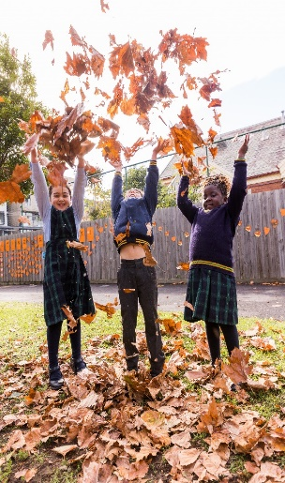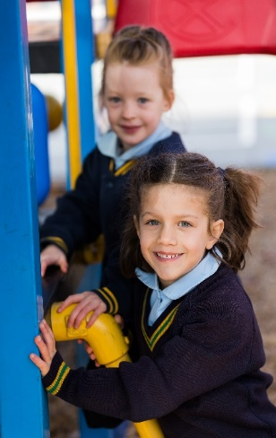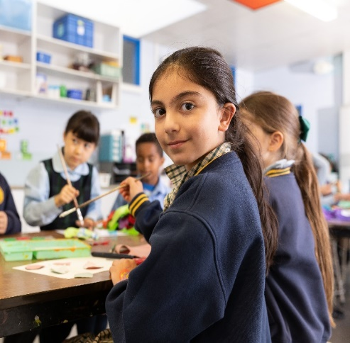

**PASTORAL CARE OF STUDENTS**

At Our Lady Help of Christians we recognise that schools are important places in promoting the emotional wellbeing of young people. Pastoral Care in a central facet to this. We believe our Pastoral Care is effectively described by the following:

* Encouraging regular dialogue between staff-students, and parents-staff
* Having a Student Wellbeing Leader
* Regular Student Wellbeing Support Group Meetings
* Regular, informed contact with specialised health professionals through the Melbourne Archdiocese
* Catholic Schools Office and local community health organisations. These include counsellors, Psychologists and Speech Pathologists

**STUDENT DIVERSITY WELLBEIN**

The Student Wellbeing/Learning Diversity Le

Personalised Learning Plans discusses and le

*“In a community that provides a strong sense of well-being, belonging and security, students (and staff) are given every opportunity to be affirmed in their dignity and worth, confirmed in their personhood, and assisted to grow to their full potential.”*

*-“Pastoral Care of Students in Catholic Schools”* (Catholic Education Commission of Victoria)

**STUDENT DIVERSITY WELLBEING LEADER**

The Student Wellbeing/Learning Diversity Leaders complete funding applications, makes Personalised Learning Plans and discusses and leads relevant social skills programs with staff and students, co-ordinates our Learning Support Officers, and meets with parents about any concerns regarding their children’s wellbeing.

**PREP BUDDY PROGRAM**

To welcome our new students commencing in Prep classes, we have a ‘Buddy’ Program, which successfully operates to ensure that each Foundation child has a warm and welcoming transition into his/her school life. Year Six students are paired with the younger ones and undertake regular activities with them to allow the Prep children to gain confidence and a feeling of security in their new surroundings. They assist initially in eating times, play games with them, have

picnics and enjoy many other projects together. This tends to remove any uncertainties little children may have as they enter the primary playground.

# SCHOOL SPORTS HOUSES

# On enrolment, each student is nominated to a School Sports House. Our Sports teams are another way in which our children experience belonging. Year Six Sports Captains are nominated for each Sports House. It is the sports captain’s responsibility to build a sense of team spirit in his/her house and encourage the younger members to feel a valued part of the team. A Sports Athletics carnival is planned during the year. Throughout the leading up to sports events, the sports captains hold *Team Spirit* afternoons where children practise their team chants and support each other in their sports practice.

# Our sports houses are based on key elements of our school history:

# *Barkly* (blue), named after the first location of the school in 1911.

The site also became the Marist Brothers Champagnat Campus of Samaritan College at 100 Barkly Street. In 2009 the site became the Deutsch Schule Melbourne.bourne (German School).

# *Toomey* (red), named after Reverend J. Toomey, the parish priest who opened the school.

# *Miller* (green), named after the street where the school office/entrance has faced since 1975.

***Xavier*** (yellow) named after the first principal (Sr. Xavier of the Mercy Order).

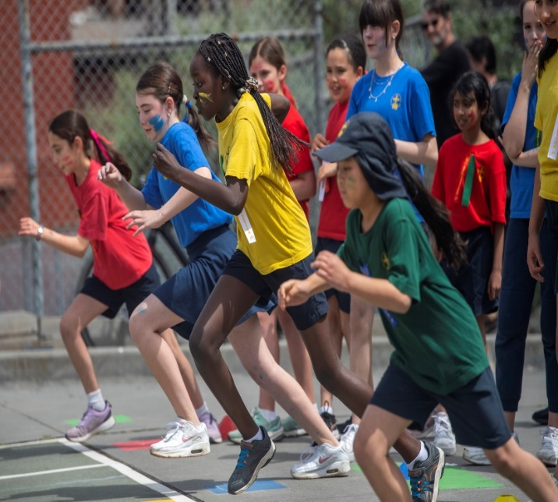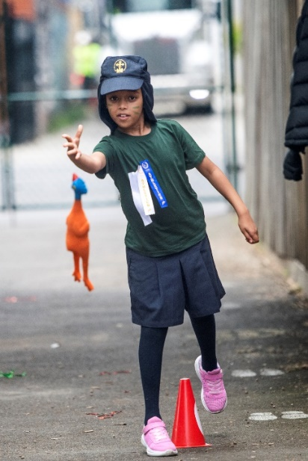

**FIRST AID**

An integral component of our pastoral care for the students is the First Aid Room, which is adjacent to the general office. The room is designed to make children feel comfortable and secure should they be unwell or distressed. The First Aid Room is available at all times to students. During recess and lunch times a qualified staff member is always rostered on First Aid duty.

If children are unwell, they are escorted to the office. On the yard, children who are sick or injured can approach a teacher on yard supervision duty, at any time. If deemed warranted, the child is escorted to sick bay by another student or if need be by a teacher.

Our policy on effective communication stipulates that any visit to the First Aid bay requires a yellow *Advice of Visit to First Aid* slip be sent home to parents*.* This is signed by the First Aid trained staff member who is responsible and describes the situation and any symptoms evident. A duplicate copy of the slip is always maintained for our files. If a child is feeling particularly unwell, a phone call will be made home to parents. Where there has been a bump to the head a phone call will also be made home. All staff have current Asthma/Anaphylactic Training qualifications. As a staff we are continually keeping abreast of the latest information on best practice with regards to children’s health.

**COMMUNICATION: SCHOOL E-NEWSLETTER**

Electronic copies of the School Newsletter are emailed to nominated parent email addresses fortnightly on Fridays. You will find it very informative. It is the main communication link between the school and home. It is essential that parents take time to read the newsletter each week, otherwise your child may miss an important event or announcement. If your child is ill and/or misses a week’s edition, you can download a copy from the school website. [www.olbrunswickeast.catholic.edu.au](http://www.olbrunswickeast.catholic.edu.au)

COMMUNICATION: THE SCHOOL APP Updat-ed

The school app can be downloaded at the App Store. Search for **Up-dated** and install on your home devices. The school uses this to distribute the school newsletter and other important information. Parents also find the Push Notification feature valuable for upcoming events and emergency notifications.

BEHAVIOUR MANAGEMENT

The Gospel values are at the heart of the relationships that we espouse at Our Lady Help of Christians School. Relationships between students themselves and between students and teachers are based upon respect for the individual and creating an environment where each member of our community has their rights upheld. Children have the right to learn, feel safe, be valued and made to feel they are an integral part of our school community. Teachers have the right to be the best teacher they can be.

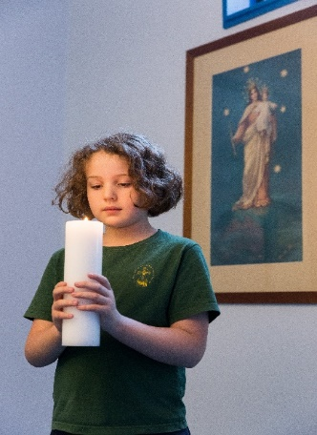

***POSITIVE BEHAVIOUR FOR LEARNING***

Each year staff receive training in Positive Behaviour FOR Learning. This looks at the behaviour of a child, and encourages (and rewards) good choices, whilst applying appropriate consequences to poor choices.

To ensure consistency across the school, a set of very clear school Agreed Ways and consequences have been created that are the same for all. In the classroom the Agreed Ways are unpacked for children and consequences explained. Teachers negotiate with children the rewards for good choices. The focus is very strongly on recognising, praising and encouraging children to make the right choices, in line with Gospel teaching.

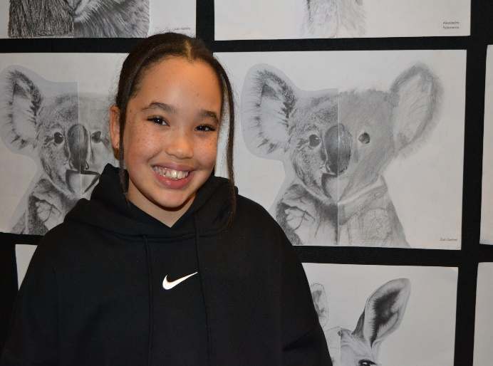

Our school also has some general school Agreed Ways that apply to playground behaviour.

Again these are implemented according to the Positive Behaviour model ensuring there are fair, consistent and relevant consequences for both good and unacceptable behaviour.

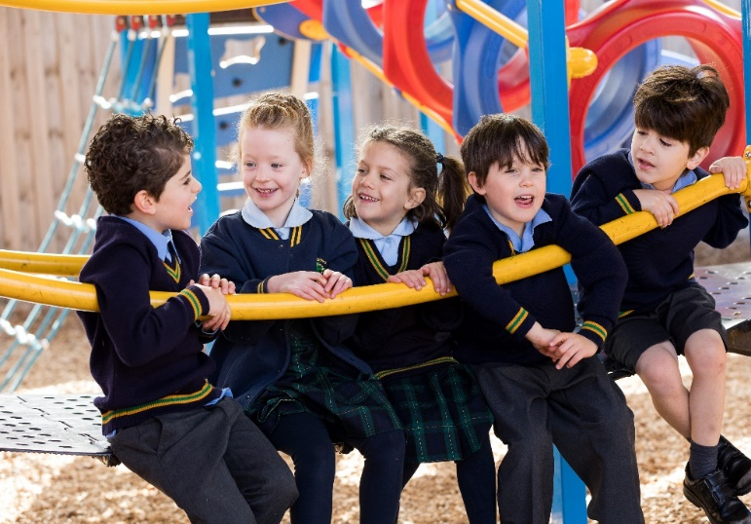

**SCHOOL / CLASSROOM AGREED WAYS**

Our Lady Help of Christians School Agreed Ways were formulated by the staff, following training in Positive Behaviour Management. A number of separate meetings followed to ensure the Agreed Ways were clear, attainable, and able to be easily and effectively understood by all children. Teachers are required to teach these Agreed Ways over a series of lessons in the first term. This is achieved in a variety of ways, including role play, persuasive writing, prayer / reflection, and a series of discussions regarding safety, respect, empathy and personal well-being.

**Our Lady Help of Christians School Agreed Ways**

**1. Follow directions.**

**2. Use your hands, feet and objects in an appropriate way.**

**3. Listen without interrupting.**

**4. Speak appropriately.**

**5. Treat all property with care.**

**6. Move safely around the school.**

**School / Classroom Rewards**

Once the Agreed Ways are taught and understood, teachers and children discuss ways for rewarding those that follow these. Although we aim for consistency in the same year level, the rewards differ from level to level. This means the Prep children are rewarded in different ways than, for example, the Year 6 children. This system of rewarding good choices is essential and is the key element of the Positive Behaviour program. Our aim is to encourage and support children to treat each other, their teachers, parents, and property well, and to be recognised in some way for doing this. Many children can be intrinsically rewarded, others require extrinsic rewards to motivate good choices. We aim to cater for all children in this program, with our goal being that children make good choices based on their knowledge, understanding and ultimately their belief that what they choose to do, is at all times, morally right and just. Having Jesus as our inspiration here makes the task that much more easy.

**School / Classroom Consequences**

Children need clear parameters for behaviour. They also need to know likely consequences for when they make poor choices. The staff have created a series of consequences for poor choices that apply to all children in the classroom. These are:

1. Warning
2. Move away from group (continue learning tasks)
3. Time away in a designated area in classroom
4. Time away in designated area in another classroom with a Reflection Sheet to complete
5. Meet with classroom teacher and Deputy Principal / Principal

Severe clause: immediate removal from classroom if posing a danger to self or others.

**Yard Behaviour**

Children’s behaviour is also monitored on yard, and a similar approach is enforced:

1. Warning (for less serious offences)

1. Teacher-walk (escorting the teacher on duty for a few minutes)
2. Time away in a designated area in yard
3. Time away in designated
4. Time away in designated area in another classroom with a Reflection Sheet to complete
5. Meet with classroom teacher and Deputy Principal / Principal

Severe clause: immediate removal from yard if posing a danger to self or others.

Staff are expected to notify parents if a Reflection Sheet has been completed. This will keep parents informed of consequences to behavioural choices.

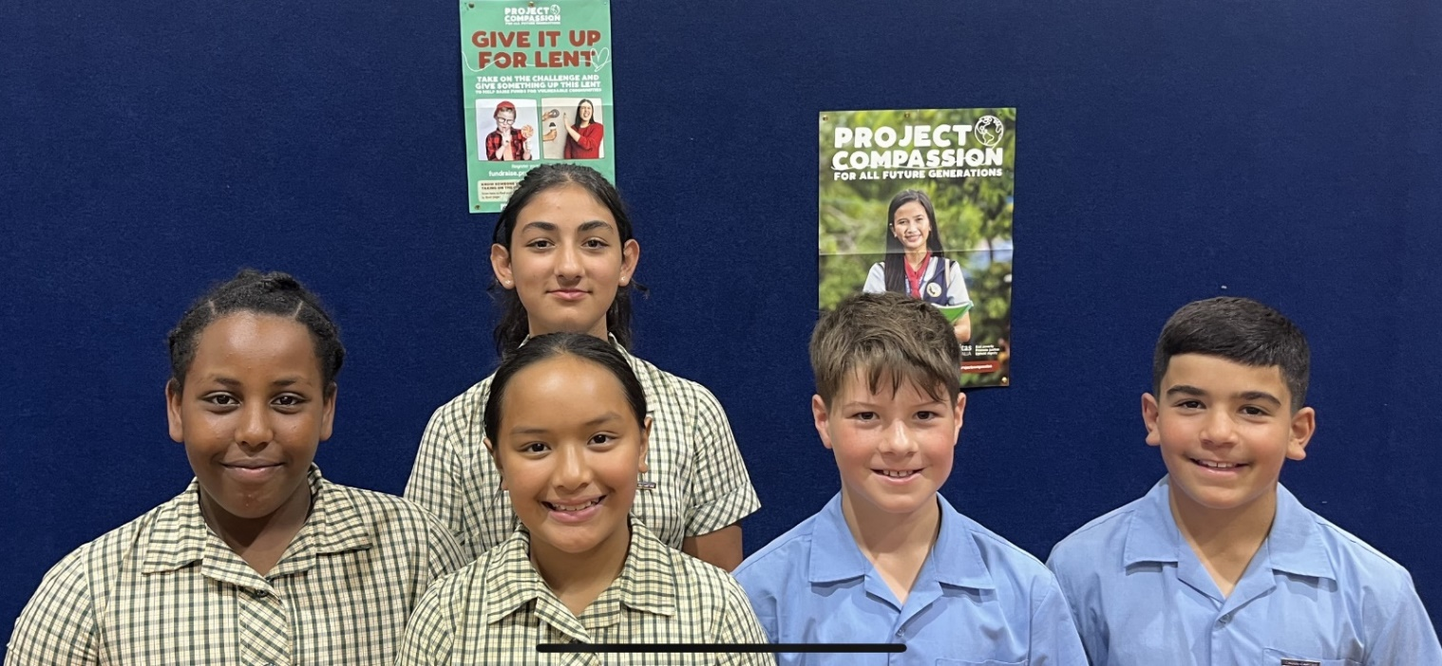

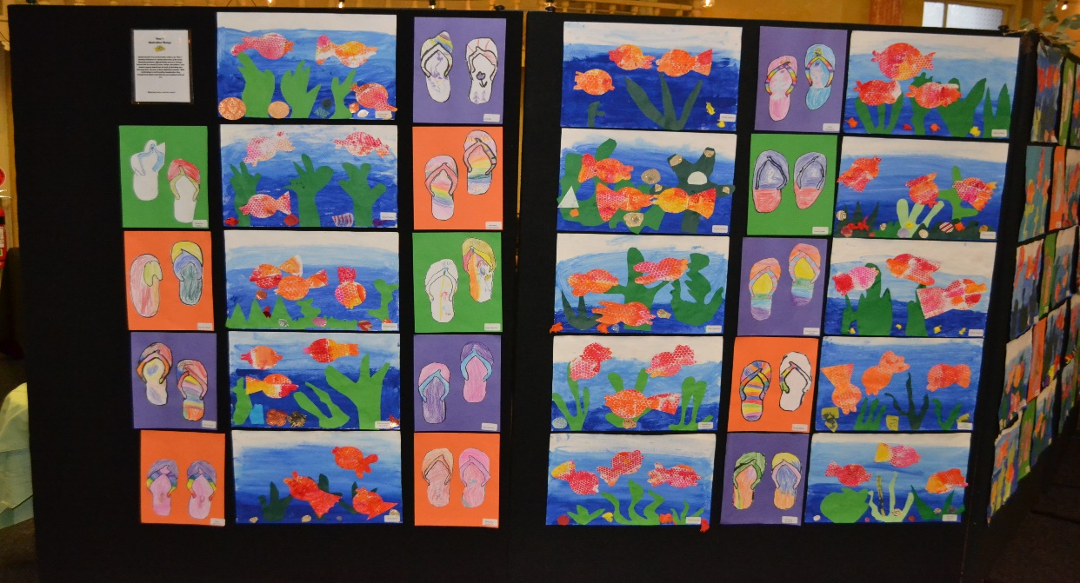

**BIRTHDAY TREATS**

We enjoy acknowledging children’s birthdays, it is however unrealistic for teachers to be cutting up cakes and handing them out during class learning time. So therefore no birthday cakes will be permitted at school. Cupcakes, individual bags of lollies or individually wrapped chocolates. These will be given out at the end of the school day. If you wish to send something for your child to share for their birthday here are some ideas:





**SENIOR SCHOOL CAMP**

At Our Lady Help of Christians School we believe that a valuable part of maturing and preparing for secondary school is participating in co-operative group activities where the participants use their skills of independence, responsibility and initiative. A school camp experience gives children the opportunity to develop and utilise these most important life skills. For this reason, a senior school camp is run each year for Year 5 & 6 children. We believe that the children should enjoy this as a culmination of their Primary School life. The camp allows the children to see themselves, their peers and their teachers in an informal atmosphere that allows the celebration of firm and fond friendships before embarking on the ‘big world’ of secondary school. We alternate our camp them each year from

Beach theme to Bush theme in the following year.

**PARENT PARTICIPATION**

There is overwhelming evidence that children who witness their parents actively involved in aspects of school activities are considerably advantaged in their learning and attitude to learning. Our aim is to provide children with an example of community working together, to help parents to assist teachers in the total education of the child, and to allow parents to become aware of and develop an understanding of the school program.

We encourage our parents to become involved in many, many ways. The following are some examples:

* The Parent Association (Meets monthly. Objectives – fundraising and connectedness)
* Class Parent Reps appointed for each class
* Classroom Activity and Inquiry Immersion Sessions, eg. cooking, art activities, etc.
* Curriculum Information Sessions
* Literacy Parent Helper Program (Literacy support in the classrooms. School provides the training for this and parents are asked to sign a Code of Conduct)
* Parent/Teacher/Student Learning Conversations - three times a year
* School Masses at beautiful Our Lady Help of Christians Church
* Annual Mother’s Day and Father’s Day Breakfast
* Second Hand Uniform Stall

In addition,class teachers are extremely appreciative of any assistance provided by parents who have a little spare time. Help with activities, such as reading, covering books or other requirements as needed, are always most welcome.

**All parent helpers are mandated to have a current ‘Working With Children Check’ before they assist in the classroom and sign a code of conduct as part of the new Child Safety Government requirements.**

# PARENT ASSOCIATION

The Parent Association at Our Lady Help of Christians School is a group of dedicated parents within the school community, both working and non-working, with children across all year levels, who come together and volunteer their time and/or services for the benefit of the school.

Their aims are:

1. To act as the communication medium between the Parent Association and each of the families within a class.   
2. To support parents within a particular classroom in times of particular need   
3. To organise social events that would increase ***social connectedness*** for families within a class   
4. To engender the support of all families for Parents’ Association events and ***fundraising activities***

These funds enhance our children’s learning and help to ensure our children have a safe,

comfortable and up-to-date working environment offering broad-based curriculum and

co-curricular activities.

Throughout the year we aim to achieve a balance between social and fundraising activities, undertaking a broad range of efforts, in the hope that the diversity can allow ample opportunities to a large cross-section of parents to volunteer their assistance / services at differing times of the year.

The following are examples of events organised by the Parent Association throughout the year:

* Welcome BBQ
* Mothers’ Day and Fathers’ Day Stalls
* Children’s Disco
* Annual Triathlon
* Annual Fundraising events – Parent Nights and Special Lunch Days

**PARENT REPS**

BBQ Nights

*Pizza alfresco* Night

Mother’s Day and Father’s Day Stalls

Mother’s Day Dinner

Fathers’ Dinner

Children’s’ Discos

Walkathon

Movie Mornings

Hot Food Days

Chocolate Drives

Family Rock ‘n Roll Night

Children’s Art Calendars

Trivia night

Each class has one designated Parent Representative, whose role is to:

* Organise a parent / family social event for each class at least once a year. This is in keeping with our vision of ***connectedness*.**
* Take on a pastoral role, in leading parents of each class to look after another family if in need or crisis. This follows our need to stand out as a Christian community.
* Meet with the Principal (when required).
* Be a contact for other parents should they have a general query or suggestion.

Parent Reps must have a current **‘Working With Children Check’ and sign the Child Safety Code of Conduct.**

**SCHOOL ADVISORY COUNCIL**

The School Advisory Council (SAC) is composed of parents, staff, our Parish Priest Fr. Dr Brendan Reed STD and Assistant Priest Fr. Tien Tran. The SAC meets each term and is an invaluable asset to our community and plays an important role in supporting the work of the Principal by:

* Promoting the school’s Catholic ethos and culture
* Articulating and enacting the School’s vision and mission
* Promoting faith formation and development
* Implementing capital resource planning and maintenance
* Disseminating information about the School in accordance with SAC Terms of Reference
* Implementing School policies as required
* Communicating School and parish matters, including approval of the school Annual Report
* Giving advice on issues such as enrolments, school improvement plans and enrolment trends

**PARENT/TEACHER/STUDENT LEARNING CONVERSATIONS AND REPORTS**

A Parent/Teacher/Student Learning Conversation or *Meet the Teacher* is held early in the first term each year. This is to allow the important passing on of information, and to establish a starting point for the development of the strong relationship between the parent, teacher and student that will maximise your child’s learning.

Additional Parent/Teacher/Student Learning Conversations are held at the middle of the year (Semester One) If, however, you have any concerns or queries, please feel free to contact your child’s teacher to arrange a convenient meeting-time. Written reports on your child’s progress will be issued at the end of Semester One and Semester Two.

Parents will be able to make bookings through the on-line Student Interview App that we advertise in our newsletter.

**EXCURSIONS / INCURSIONS**

Each Year level will prepare a special excursion activity to enhance the students’ learning. This has a direct curriculum focus – either to kick-start a unit of study in an exciting way or to consolidate the learning that is taking place. Throughout the year, we also organise regular incursionswhen we invite experts in their field to come to school and give a presentation or run programs for the students.

Whether they are at school or away from school, Excursions and Incursions are an important part of the school program that provide valuable *shared experiences* for teachers to draw out important learning outcomes. An excursion levy is built into our Book and Stationery Levy.

**FINANCE**

CURRICULUM LEVY

The Curriculum Levy is reasonably priced considering ever increasing costs to the school. These funds allow the school to provide programs and resources for classrooms, Library and each subject taught. It also covers most of your child’s stationery needs, photocopying plus excursion costs and swimming program throughout the year.

# SCHOOL FEES

School Fees are invoiced annually in February and are payable in instalments, as published in the school’s newsletter, normally at the commencement of each term. The School Office does not

re-issue statements throughout the year unless fees are overdue. Special arrangements (weekly, fortnightly or monthly instalments) are also an available option – see School Bursar for further details.

Methods of payment include Cash, Cheque, Direct Debiting from cheque account, Credit Card, Internet Banking and EFTPOS. Payment should be returned in an envelope with your child’s name and class marked on the front if you are unable to call into the school office.

**Parents facing difficulties in meeting their school fee obligations are urged to contact the**

**School Principal to discuss their special circumstances and make arrangements for payment.**



**ABSENCES FROM SCHOOL**

You are expected to notify the school if your child is unable to attend school for any reason.

This should be done through the school website, *Student Absence Reporting* tab on the morning

(or in advance) of the absence **prior to 9.00am**.

If your child is also absent for part of a day (late arrival or early dismissal) due to an appointment, family reason, etc, then we also ask parents to report this part-day absence through the same Student Absence Reporting tab in advance of the absence, where possible.

We discourage families being away from school during the school term due to family holidays. This disrupts the flow of learning for the child who is away, and also for the other children in the class. If a child is going to be absent from school for an extended period, then permission must be sought from the Principal for this to occur. This is Victorian Education Department policy.

If the school is not notified of a child’s absence by 9.30am, a text/SMS message will be sent to the parents informing them of this student's non-arrival.

**ILLNESS**

You are required to keep your child at home if they are ill or if they have a contagious condition such as chickenpox, school sores and other infections. This is in fairness to all - your child, other classmates and school staff. It will also assist in the recuperation of your child too.

###### LATE PASS / EARLY RELEASE FORM – PASSTAB

###### Children who arrive at school late (after 8.55 am) must be accompanied to the office by a parent/carer. The parent must sign in the child using the electronic IPAD (Passtab) in the main office. Children who leave school during school hours must be signed out by a parent via the Passtab. A notification is automatically emailed to the classroom teacher and school office detailing this early exit or late arrival to school. These absences are then detailed on the child’s Student Report for the semester.

###### EXTENDED ABSENCE

Please notify your child’s teacher and Principal if your child will be away from school for an extended period such as for a family holiday. Permission needs to be sought from the Principal for a child’s

absence prior to a holiday being booked and paid for. We discourage children and families from taking holidays during non-school holiday times due to the disruption this can cause to your child and other children’s learning. **The school will not provide extended absence home learning as this simply legitimises a child being away from school during non-holiday times.**

**CHANGE OF ADDRESS / PHONE NUMBER/EMAIL**

The office must be advised immediately of any change to these details so that we know where to contact you if an emergency should arise. Simply send your new details to school by email to our registrar, Cathy at [cwindsor@olbrunswickeast.catholic.edu.au](mailto:cwindsor@olbrunswickeast.catholic.edu.au).

**EMERGENCY CONTACT PHONE NUMBER**

Please ask someone you know to act as your emergency contact for your child. Should we be unable to contact you in an emergency situation involving your child, we will contact your Emergency Contact to seek instructions. You must provide the school with the name, address and phone number of this person. ***Do not*** list yourself as the Emergency Contact - ask a relative or friend who does not live at your residential address.

**STUDENT DRESS CODE – UNIFORM**

Summer Uniform:

Black shoes - recommended with closed toe. There is a choice of two school hats - either the Legionnaires Hat (one size fits all) or Slouch Hat (S, M or L) can be worn. If cold, the navy jumper &/or Bomber Jacket can be worn. Tracksuit tops can only be worn on Sports Days.

**GIRLS**: Summer dress, white socks (above the ankle), hair ties to be in school colours only (gold, green, navy) or grey shorts with blue shirt.

**BOYS**: Short-sleeved blue shirt, grey shorts, grey socks.

Winter Uniform:

GIRLS: Dark green school checked tunic with navy-blue tights or navy socks or grey trousers black shoes; long sleeved blue shirt, navy school jumper and bomber jacket

BOYS: Grey trousers/shorts, long sleeved blue shirt, navy school jumper and bomber jacket, grey socks, black shoes.

|  |
| --- |
| **SPORTS/ P E DAYS:**  **GIRLS: school tracksuit or navy - blue shorts, gold logo optional: sports team T-Shirt.**  **BOYS: school tracksuit or navy - blue shorts, gold logo optional: sports team T-Shirt.** |

**SCHOOL UNIFORM SHOP:**

Our School Uniform sales are sold and managed by Spartan School World.

Parents have 2 choices to purchase School Uniforms:-

* Visit in store – School World Lower Plenty, 97 Main Road, Lower Plenty VIC 3093
* Online: [www.spartanschoolworld.com.au](http://www.spartanschoolworld.com.au)

Select Our Lady Help of Christians Primary School from the ***“FIND MY SCHOOL”*** list. Choose free weekly delivery to school or home/private address.

Or you may Click and Collect by ordering online and collect in store

Parents/Carers may also go to the school website[*www.olbrunswickeast.catholic.edu.au*](http://www.olbrunswickeast.catholic.edu.au) *,* select the Uniform Tab from the ‘home page’ to order uniforms on-line



Second hand uniforms: The Parents Association accepts donations of used school uniforms. These are sold throughout the year for a small note or gold coin donation. These second hand uniform stalls are advertised throughout the year in our school newsletter.

**IMPORTANT POINTS REGARDING DRESS CODE:**

Jewellery: No nail polish, make-up or jewellery is allowed. For pierced ears, studs only are acceptable due to danger of injury when playing games. Chokers, dangly earrings or chains worn outside clothing are considered too dangerous for school days.

Hair: Boys and Girls with longer than collar-length hair must have it tied back at all times with plain blue, green or yellow elastic or ‘scrunchie.’ Hair bands can be worn, but must be plain blue, green, yellow or in Summer: checked (if same material as uniform).

All shirts are to be tucked in if wearing the jumper/bomber jacket.

Scarves /parkas: are not to be worn in classrooms, scarves are not preferred on yard at recess times for safety reasons. However, if worn, only in school colours: dark green, yellow, navy blue (self-coloured – not speckled /patterned/striped, etc.) Parkas can only be worn if a school jumper is worn underneath.

Hats: regardless of time of year, no hat to be worn at recess/lunch times other than a school hat/school beanie

Bomber jackets can be worn at any time. For Year 6’s, the bomber jacket is offered as a graduate jacket version with all Year 6 students’ names and heading: ***Class of 2025.***