**Our Lady Help Of Christians**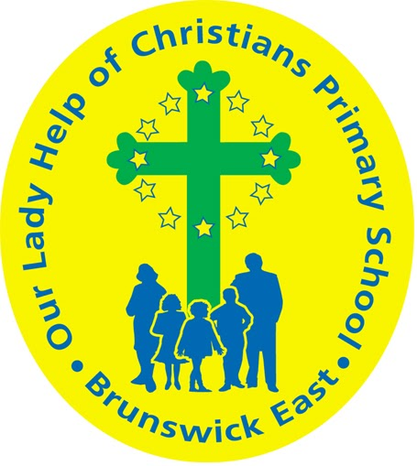

**Term 2025 Overview**

Year Level: Prep Teachers: Emilie Owen & Megan Holmes

eowen@olbruswickeast.catholic.edu.au mholmes@olbruswickeast.catholic.edu.au

Over the term, the students will be working towards the learning outcomes and concepts outlined below.

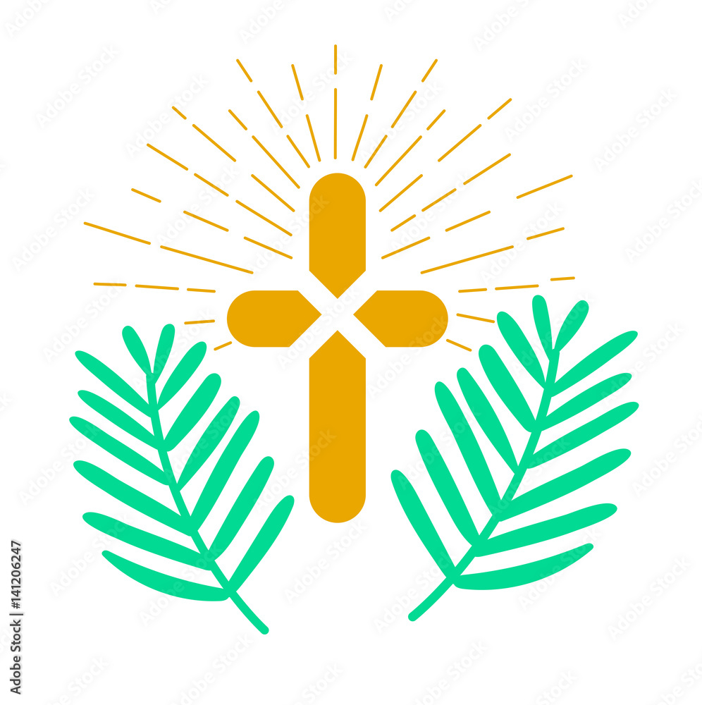

| **RELIGIOUS EDUCATION**  **PRAYER**  In Religious Education, students will begin to develop their understanding of  the liturgy, and explore the purpose of prayer. They will learn that prayer is a time where we talk to and listen to God. Students will be introduced to a sacred prayer space in the classroom where they will learn about the significance of the different objects that make up this space. Students will learn some of the behaviours and actions of prayer, including making the Sign of the Cross.  Students will reflect on the life of Jesus and identify ways that he was kind and caring. They will plan to use Jesus’ example in their daily lives, by making good choices.      **LENT and HOLY WEEK**  Students will begin to learn about Lent and Holy Week. They will listen to stories of the *Lost Sheep*, *Palm Sunday and The Last Supper.*  Through these stories, and in keeping with the season of Lent and Holy Week, students are introduced to Jesus Christ as the one who loves us. | **ENGLISH**  **READING**  The students will be:   * recognising letter names and spoken sounds * breaking words apart into sounds and blending back together to help us read them, such as c-a-t = cat * displaying reading behaviours, such as: correctly holding a book, pointing to the words and discussing the pictures * identifying the difference between letters, words and pictures * introducing basic features of a book eg: front cover, author, title * exploring heart words, such as: the, my I, of are.   **WRITING**  The students will be:   * developing awareness of directionality when writing  e.g. from left to right, top to bottom * writing their name using correct lowercase letter formation and starting points * using known letters to represent the sounds they can hear in words * holding a pencil correctly * attempting to construct a sentence to match their learning and have an adult scribe their story ,if needed * strengthening fine motor skills, such as cutting,   drawing, threading and squeezing.  **SPEAKING & LISTENING**  The students will be:   * using speech to request and obtain relevant information * understanding and following simple instructions * developing good listening behaviours - ‘Whole Body Listening’ * breaking words apart into sounds orally. |
| --- | --- |
| **MATHEMATICS**  NUMBER  The students will be:   * reading, writing and recognising numbers 0-20 * counting forwards and backwards using numbers 0 - 20 * partitioning numbers to 10 : e.g. 5 is the same as 2 plus 3, or 4 plus 1 * counting each object once when counting a group of objects to 20 * subitising small collections of objects.   ALGEBRA  The students will be:   * recognising, copying and describing different repeating patterns.   MEASUREMENT  The students will be:   * identifying basic two dimensional shapes, such as triangle, rectangle, square and circle * sorting, classifying and comparing shapes according to features * recalling the days of the week and relating to daily events * using the terms morning, lunchtime, afternoon and night time.   SPACE  The students will be:   * describing the position and location of themselves and objects | **INQUIRY**  COMPELLING QUESTION:  **How can I keep myself safe, happy and healthy in my school community?**  Throughout Term One, students will develop their understanding of how our choices help us to be responsible, healthy and safe. Students will identify different settings where they can be active and how to move and play safely. Students will become active citizens by being in control of their personal health and safety.  UNDERSTANDINGS:   * In our community there are people who keep us safe. * I can identify actions that promote health, safety and wellbeing. * The choices I make help me to be responsible, healthy and safe. * Self managers develop routines and habits to be independent. |

| **PHYSICAL EDUCATION**  **Mr David Witchell**    In Physical Education classes this term, the students in Prep will learn simple rules for safe movement and how to follow instructions. They will learn running games such as relays and fruit salad. The students in Prep will begin to develop basic motor skills, such as running, skipping, throwing, catching and bouncing. | **STEM**  **Science, Technology, Engineering & Mathematics**  **Mrs Joanna Hanson**    In STEM in Term One, students will explore the question “How do things move?”. They will learn about positional language and learn to follow simple sequenced steps to create a solution. Students will pose and answer questions about how different forces affect the movement of objects. They will explore how different strengths of pushes and pulls affect the movement of objects. Students will compare how different objects move depending on their size and shape. They will be introduced to the Design Process and use what they have learnt from the unit to create a movement game. Throughout the unit, students will work collaboratively with a partner and focus on turn taking and sharing equipment. |
| --- | --- |
| **VISUAL ARTS**  **Mrs Maegan Whiteley**    In Term One of Visual Art, Foundation students will develop essential art room routines and expectations through structured activities. They will explore safe practices, collaborative behaviours, and the importance of preparation in the visual art room. Following this, students will be introduced to dots and patterns, drawing inspiration from Yayoi Kusama’s vibrant and immersive artwork. Students will experiment with dot-making techniques and three-dimensional surfaces to build foundational skills in pattern recognition and self-expression. Later in the term, they will explore colours and patterns from around the world, creating artworks, such as African-inspired paper bead necklaces. | **ITALIAN**  **Mrs Angela De Francesco**    Students will be introduced to the Italian language. They will learn to use everyday greetings with their teacher and peers and understand that different words are used in Italian to greet different people according to their relationship. Students will discover the unique shape of Italy and where it is located on the world map. They will learn how to introduce themselves and will participate in songs to consolidate their Italian vocabulary. |

| **SOCIAL and EMOTIONAL LEARNING ( SEL )**  Students will explore social and emotional literacy through our ‘Resilience, Rights & Respectful Relationships’ curriculum. Students will develop a vocabulary for emotions to help build self-awareness. They will be exploring emotional literacy in the classroom and identifying what emotions look like, sound like and feel like. Students will also be learning about the concept of help-seeking. They will identify situations in which they may need to ask for help and the people that can help them at school.  Throughout Term One, the students will be developing their **self management** skills in the classroom and playground. They will be provided opportunities to demonstrate what a self manager looks like to support their independence skills.  COMPELLING QUESTION:  How can I be ready to learn at school?  UNDERSTANDINGS:   * Everyone has emotions which we experience at different times. * Routines help us to get ready for learning. * There are always people at school to help us with a problem or question. | **TIMETABLES**  **Prep M**   | STEM | Tuesday | | --- | --- | | ITALIAN | Thursday | | PHYSICAL EDUCATION | Tuesday | | VISUAL ARTS | Thursday | | LIBRARY | Monday |   **Prep E**   | STEM | Tuesday | | --- | --- | | ITALIAN | Thursday | | PHYSICAL EDUCATION | Tuesday | | VISUAL ARTS | Tuesday | | LIBRARY | Monday |     Have you downloaded the Seesaw App onto your device to be informed about your child’s learning?  Please contact your child’s class teacher to gain access. |
| --- | --- | --- | --- | --- | --- | --- | --- | --- | --- | --- | --- | --- | --- | --- | --- | --- | --- | --- | --- | --- | --- |