**Our Lady Help Of Christians**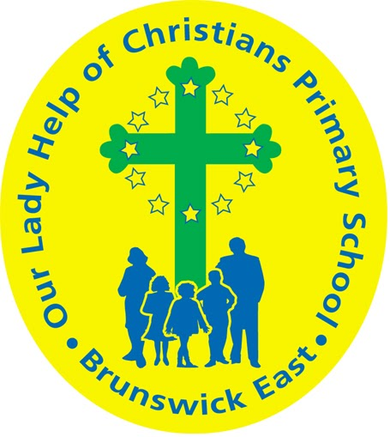

**Term One 2025 Overview**

Year Level: One Teachers: Renee Bouvier 1B

Karina De Giusti ( Mon & Tues) & Dani Criscione ( Wed- Fri ) 1DK

rbouvier@olbruswickeast.catholic.edu.au [kdegiusti@olbruswickeast.catholic.edu.au](mailto:kdegiusti@olbruswickeast.catholic.edu.au)   
 dcriscione@olbruswickeast.catholic.edu.au

Over the term, the students will be working towards the learning outcomes and concepts outlined below.

| **RELIGIOUS EDUCATION**  During Term One the students will focus on The People of God and the Resurrection of Jesus. They will explore the purpose of prayer in their own lives whilst reflecting on God’s people in the Old Testament of the Bible.  Students will learn the prayers of our Church, and begin to create their own personal prayers. Students will build their understanding on the many ways we can pray and practise these daily.  The students will be:   * exploring the purpose of prayer and identifying the key elements of a prayer space * identifying people in the Bible who had an important relationship to God and discussing the many ways we can strengthen our relationship with God * identifying Lent as a time of change when God helps people to grow to be better people * retelling the story of The Road to Emmaus and the Ascension of Jesus. | **ENGLISH**  Throughout Term One, our focus for reading is developing decoding skills using *Little Learners Love Literacy ,* an evidence-based structured literacy program. Students will revise, practise and apply skills when reading, writing, speaking and listening.  READING & VIEWING  The students will be:   * building their understanding of new phonemes/graphemes * decoding unfamiliar words, including multi-syllable words * segmenting words for spelling and apply phoneme/grapheme knowledge * understanding morphology – base words, adding suffixes (ing, er, ed, tion) and prefixes * developing their understanding of what a homophone is * developing and applying their understanding of what a contraction is * making text connections - *What does this story remind you of?* * sequencing and retelling the main parts of a text * responding to literal and inferential comprehension questions.   WRITING  The students will be:   * writing recounts about their experiences by focusing on the correct sequence of events * consolidating letter formation and placement on the dotted thirds * writing information texts * using correct punctuation * continuing to develop spelling strategies and focusing on particular spelling patterns.   SPEAKING & LISTENING  The students will be:   * identifying and creating rhyming words * speaking clearly in front of the class * listening attentively by tracking the speaker. |
| --- | --- |
| **MATHEMATICS**  NUMBER  The students will be:   * counting forwards and backwards by ones to at least 120 * making two-digit numbers using ten-frames * adding and subtracting numbers using a variety of calculating strategies including part part whole and physical materials * partitioning one- and two-digit numbers in different ways using physical and virtual materials.   STATISTICS  The students will be:   * collecting and recording data in various ways including using digital tools, objects, images, drawings, lists, tally marks and symbols. | **INQUIRY**  Throughout the first term, students will explore their local community and recognise how to be an active member. Reflecting on the choices they can make to keep themselves safe and building on their knowledge of people in their community who keep them safe.  COMPELLING QUESTION: *How do the places, people and symbols in our community support our safety and wellbeing?*  UNDERSTANDINGS:  Within our community there are places where we can be safe and active.  Our community has significant places that are special to us.  There are people in our community who keep us safe.  We can keep ourselves safe and healthy by making good choices and following health messages.  Relationships are key to building strong communities.  Everyone has strengths that they contribute to make communities positive places. |

| **PHYSICAL EDUCATION**  **Mr David Witchell**    In Physical Education classes this term, the students will continue to develop their basic motor skills such as running, throwing, catching, bouncing and striking. They will perform these skills in small groups and game situations. The students in Year One will also develop their more complex skills such as over – arm throw, dribbling and striking balls. | **STEM**  **Science, Technology, Engineering & Mathematics**  **Mrs Joanna Hanson**    In STEM in Term One, the students will learn about the fundamentals of forces and mechanics. They will observe the way different shaped objects move, depending on the size and shape of the object and the forces exerted on the object. Students will explore how different strengths of pushes and pulls affect the movement of objects and explore how these are used in the design of games. They will identify and experiment with components such as wheels, balls, pulleys, slides and springs. Students will use Makedo Kits to invent, test and refine prototypes of their own Arcade Games, working collaboratively through the Design Process. |
| --- | --- |
| **VISUAL ARTS**  **Mrs Maegan Whiteley**    In Term One of Visual Art, Year One students will embark on an exciting journey into the world of dots and patterns inspired by Yayoi Kusama. Through exploration, they will experiment with creating patterns using different materials, starting with drawing before progressing to three-dimensional work. Students will create patterned pumpkins using plasticine, learning how repetition and shape can transform simple objects into expressive artworks. Later in the term, they will explore cultural patterns from around the world, including Native American dreamcatchers and Scandinavian folk art, developing an appreciation for artistic traditions while experimenting with symmetry and colour. | **ITALIAN**  **Mrs Angela De Francesco**    In the unit ***La Nostra Comunità***, Our Community, students will explore the concept of community by identifying key community members and their roles in Italian. They will learn vocabulary related to various professions, such as ***medico*** doctor, ***insegnante*** teacher**,** and ***vigile del fuoco*** fireman. Through engaging activities, students will practise speaking, listening, reading, and writing in Italian, reinforcing their understanding of professions and their importance in daily life. They will also have opportunities to apply their learning in conversations, role-playing scenarios, and interactive exercises. |

| **SOCIAL and EMOTIONAL LEARNING ( SEL )**  This term students will engage in the Berry Street model focusing on what it means to be ‘ready to learn’ and developing strategies to support their social/emotional development. Students will develop a ‘ready to learn plan’ and identify strategies that help their ability to learn and self regulate. Students will follow the Resilience, Rights and Respectful Relationships program and explore their different character strengths and how our strengths help us to be successful.  We will also continue to remind students of the expectations and behaviours including in our Positive Behaviour for Learning Matrix. These positive behaviours will foster a shared understanding among students of how to contribute to a positive and conducive learning environment at Our Lady Help of Christians.    COMPELLING QUESTION: How do I know when I am ready to learn?  UNDERSTANDINGS:   * Managing my feelings and emotions helps me be ready to learn. * Routines help us to be ready to learn. * I know different strategies to calm me down and help me to be ready to learn. * I can identify the different emotions I feel at school. * Understanding my emotions help me to recognise when I am ready to learn or need to use strategies to help me self regulate. | **TIMETABLES**  Library Borrowing Friday   | STEM | 1DK Tuesday  1B Wednesday | | --- | --- | | ITALIAN | 1DK Wednesday  1B Thursday | | PHYSICAL EDUCATION | 1B Wednesday  1DK Thursday | | VISUAL ARTS | 1DK Wednesday  1B Thursday |     Have you downloaded the Seesaw App onto your device to be informed about your child’s learning?  Please contact your child’s class teacher to gain access. |
| --- | --- | --- | --- | --- | --- | --- | --- | --- | --- |