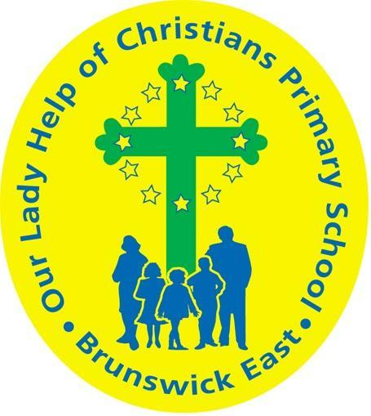
Our Lady Help of Christians
Term 3 2020 Overview

Year Level: Four Teachers: Jack Rendle & Carla Saldaneri
Over the term, the children will be working towards the learning outcomes and concepts outlined below.
RELIGIOUS EDUCATION  In Religious Education students will be undertaking two units from Coming To Know Worship & Love. In Meeting God Through Prayer children will be exploring the various types of prayer in our Catholic tradition. Students will be participating in a variety of prayer sessions and compose their own personal prayers. In Creation: Living in Harmony children will investigate the Christian tradition of stewardship and the equitable use of the earth’s resources  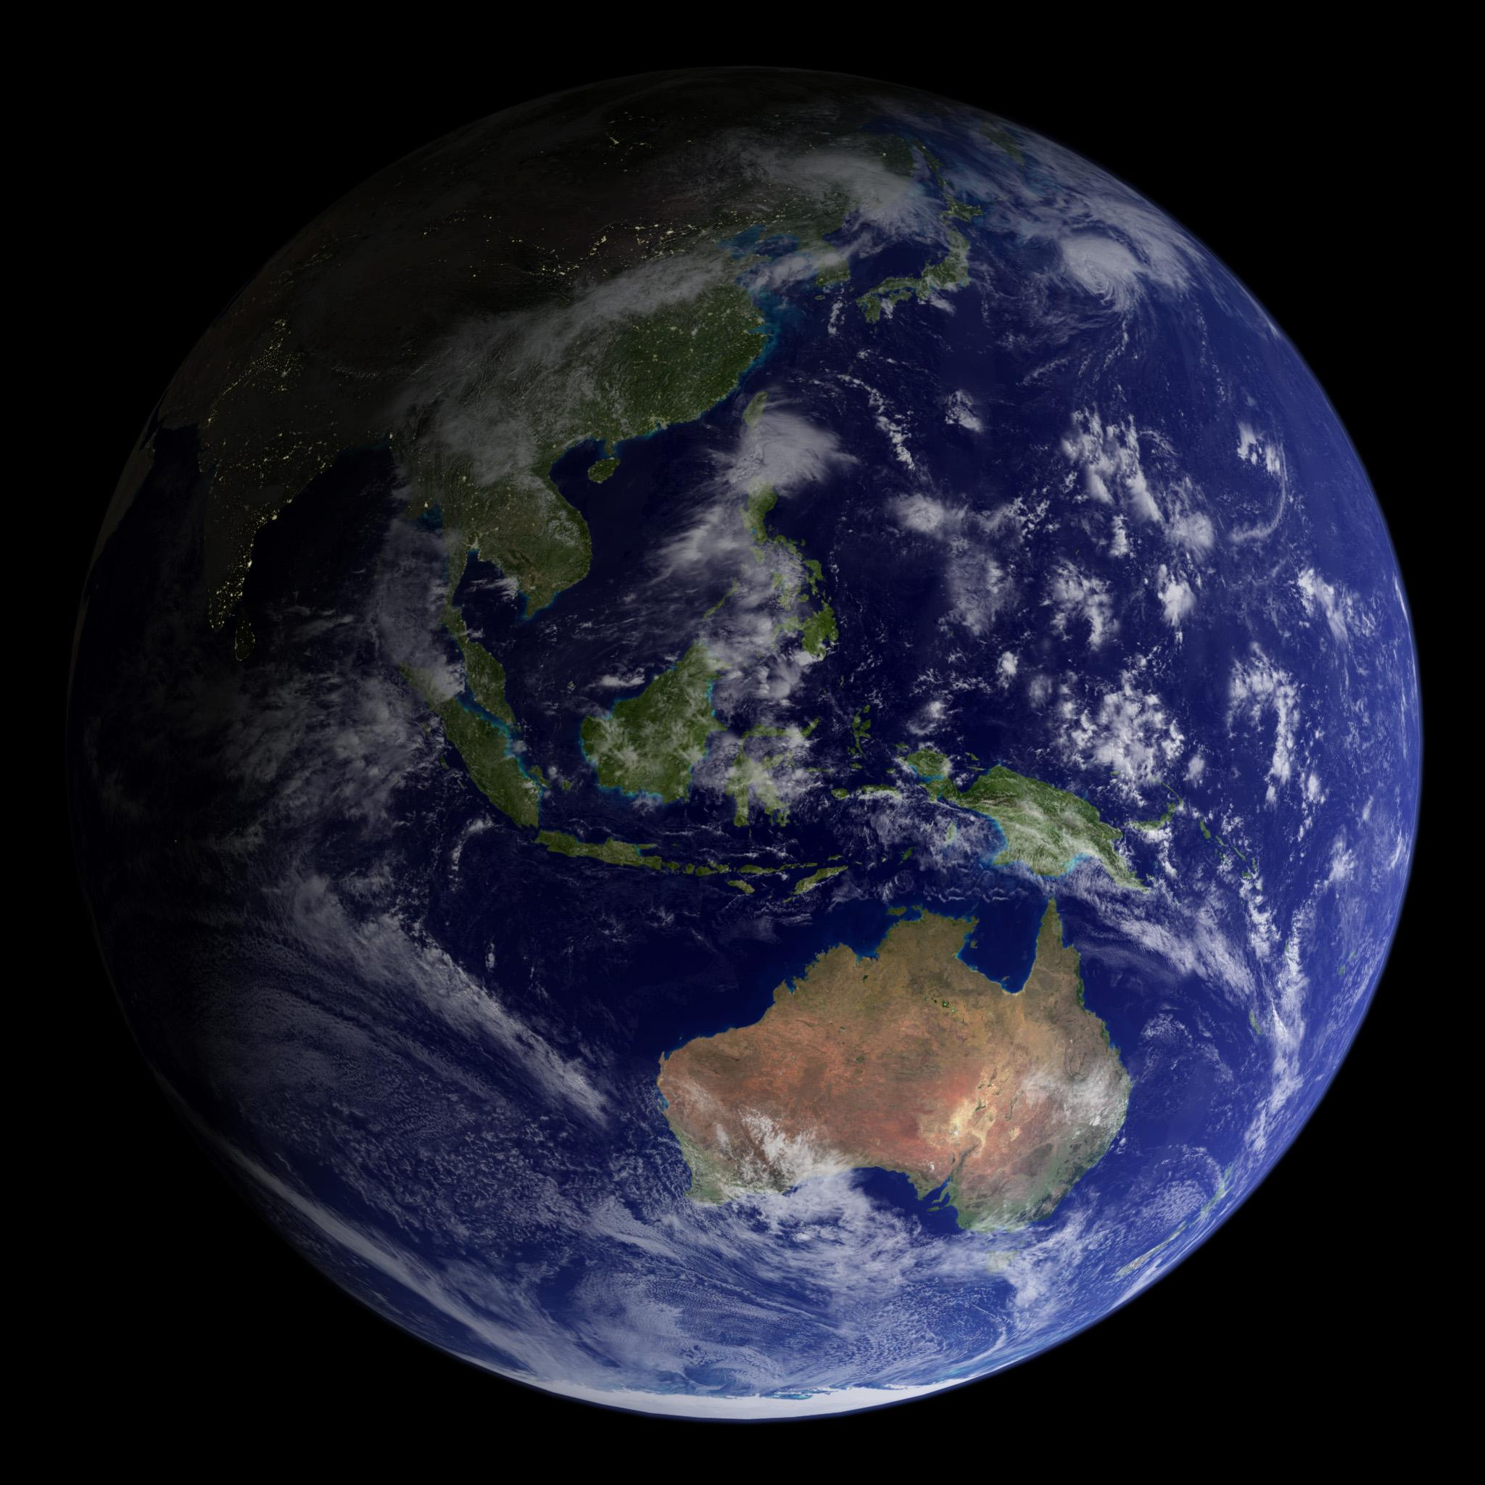 | LITERACY  In Reading & Viewing, children will further develop their comprehension strategies to gain greater meaning while reading. We will also continue to develop knowledge of spelling patterns and rules.  In Writing, students will be developing their knowledge of the structure and vocabulary of three text types; poetry, procedure and explanation. Aspects of procedure and explanation text types will support and complement our Inquiry Unit this term. Children will also continue to develop their skills in editing and proofreading their own work. In Speaking & Listening, children will be focussing on oral presentations relating to Inquiry. They will also be participating in daily Google Meets and weekly Reading Groups while working remotely.  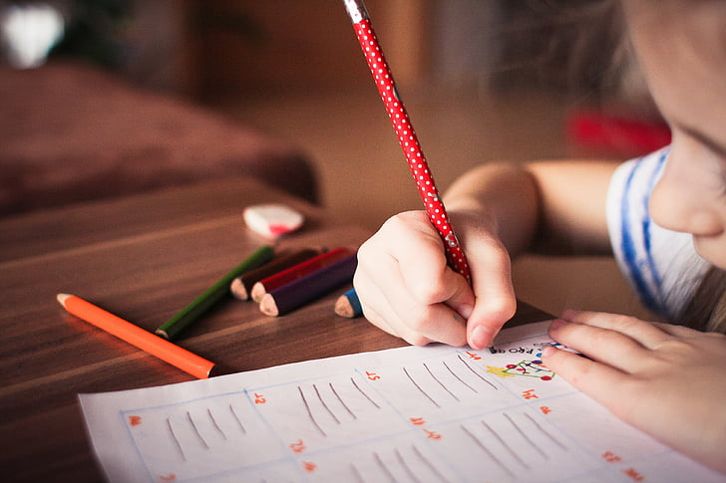
MATHEMATICS  In Mathematics students will extend and consolidate their understandings and skills in the operations of addition & subtraction. Students will further develop strategies for solving mental mathematics and continue to learn multiplication facts up to 12s. Children will explore and compare the area and perimeter of objects using familiar metric units of area and perimeter. Students will also explore through the topic of location. Opportunities to participate in Mental Maths via Google Meets will be offered during remote learning.  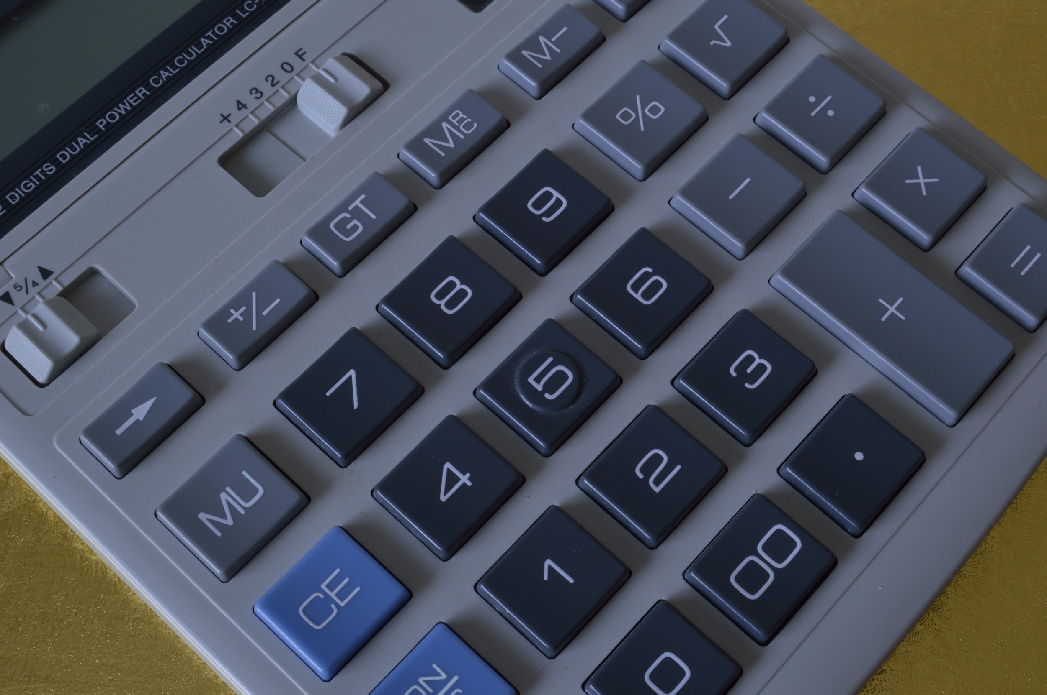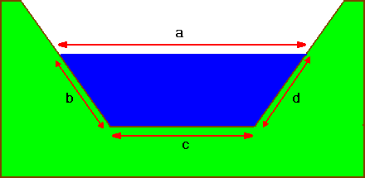 | INQUIRY  Students will learn about Science & Discovery. They will develop a deepening awareness of key scientific principles and practices and how the exploration of science changes and deepens our understanding of the world. Students will aim to build an understanding of the processes that can be used when undertaking scientific investigation, and of the importance of curiosity, questioning and research in finding out how things work and why things happen. Students will participate in various simple science experiments.  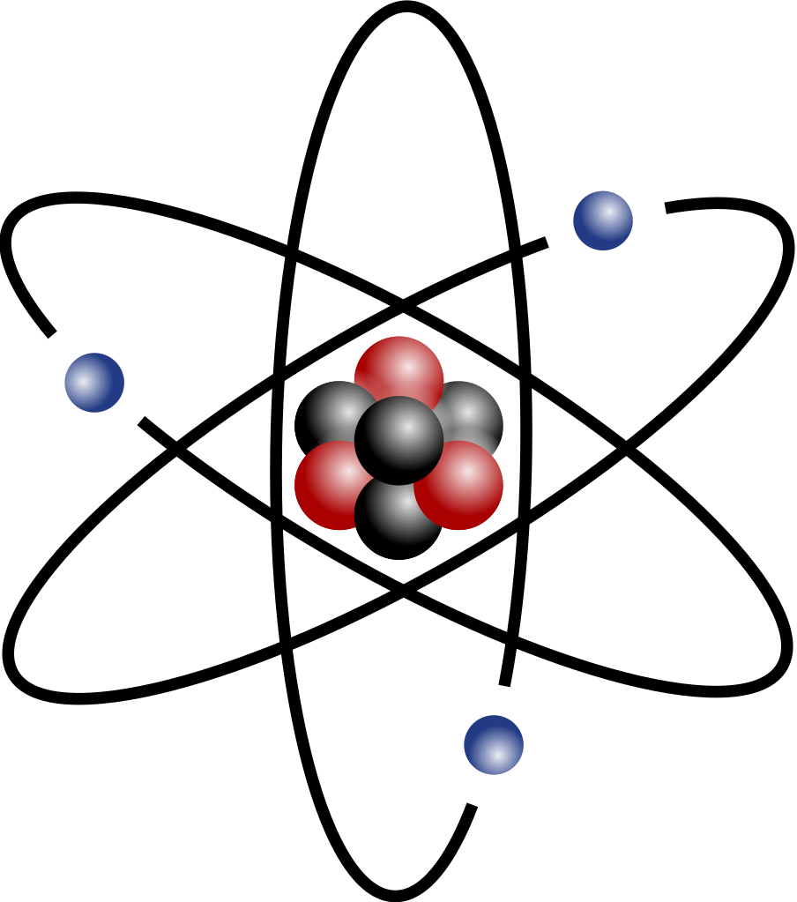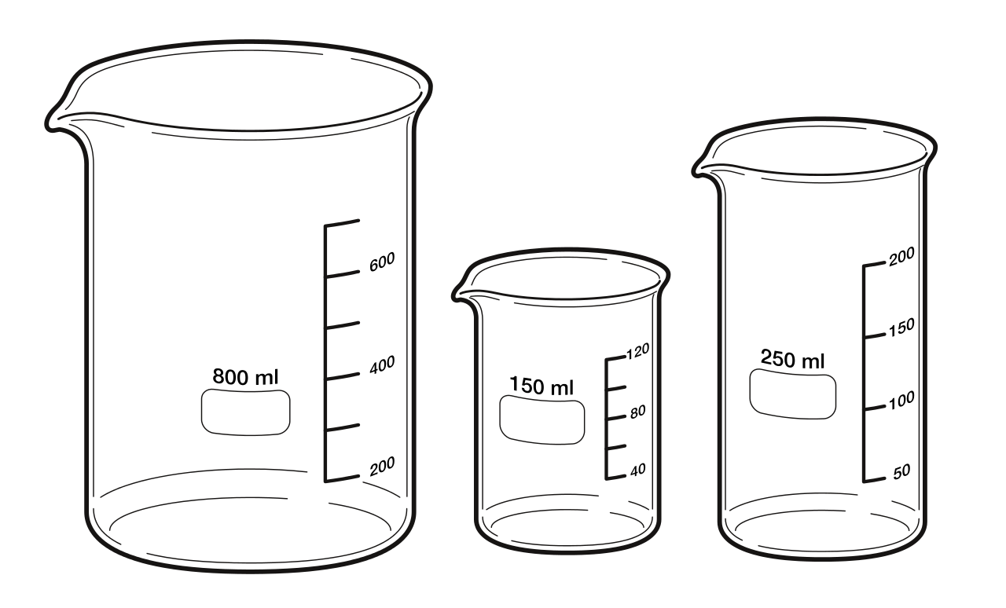

PHYSICAL EDUCATION  This term students will begin to explore their range of skills, and perform them with increasing accuracy and control in more complex movements, sequences and games. The sports used to achieve this are football and netball  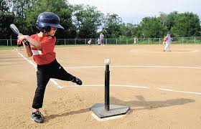 | DIGITAL TECHNOLOGIES  In Term 3, we will look at using computer software to create and conduct a survey with our classmates. We will begin through a guided survey and then students will independently create their own survey for their peers to complete.  Students will then use Google software to create visual graphs to express their data. We will explore the different types of graphs that can be used.  Through this global pandemic, I would like to wish you all the best as we resume our Remote Learning in Term Three. Stay safe!  Mr Joss
VISUAL ARTS  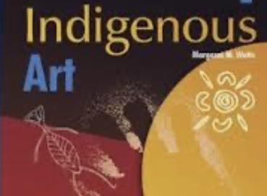  Art in Term Three will see Year Four students study Indigenous Art, considering both the traditional and contemporary approaches. Throughout the term, they will explore the role of colour when they are responding to works and creating their own. Analysis will include The work of Gloria Petyarre and her move away from the use of warm colours and natural pigments. | PERFORMING ARTS  Student’s we will be creating and writing musical compositions and performing their music to communicate ideas to an audience. The students will be using Chrome music lab and completing a number of experiments that will enable them to further explore their understanding of the elements of music, music compositions and creativity. Their presentations will show an understanding of the elements of music and the contrasts that they have created. It is time to be creative and inventive in performing arts, I can’t wait to see what the students present.
LIBRARY  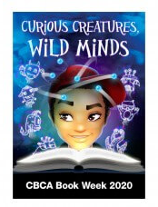  In Term 3 we celebrate Book Week themed Curious Creatures Wild Minds. Students will be read books selected from the 2020 CBCA shortlisted books and encouraged to vote on their favourite book.  Through discussion and activities we will be exploring the style of writing used by different authors.Students are encouraged to participate in the various book week activities. | ITALIAN  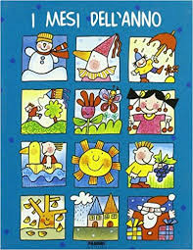  This term students in Year 4 will revise ‘i mesi’ the months of the year in Italian. We will focus on pronunciation and recognition of each of the months and rules associated with writing the months of the year.  Students will learn about the seasons associated with each of the months. They will also discover and compare seasons at the same time of the year in Italy and Australia.

