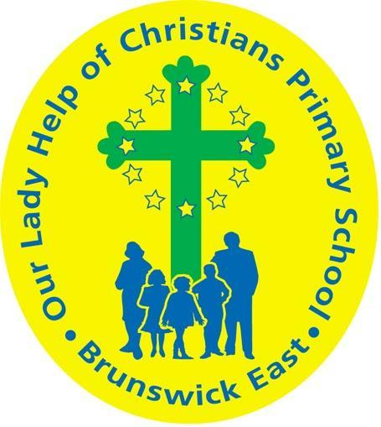
Our Lady Help Of Christians
Term 3 2020 Overview

Year Level: One Teachers: Laura Shannon & Ashlea Sandells
Over the term, the children will be working towards the learning outcomes and concepts outlined below.
RELIGIOUS EDUCATION  Creation and Stewardship of the Earth  - God created the world out of love and kindness  - Life and creation are signs of God’s beauty and goodness  - We are called to give thanks for the gift of creation  - Each person can make a difference to improve the environment  How we Pray  - People gather together to pray  - There are many different ways to pray  - Our Father and Hail Mary are important prayers that we say during Mass  - Types of prayers - thanks, petition, sorrow and praise | ENGLISH  In Reading, Writing and Speaking & Listening we will focus on:  - Literal comprehension - understanding the text  - Re-reading and self correcting if our reading does not make sense  - Continuing to practise segmenting words into sounds and exploring the THRASS chart and spelling patterns  - Spelling vowel digraphs such as ‘ow’, ‘ai’, ‘oi’ and ‘er’  - Reading with fluency and expression  - Identifying different punctuation and how they affect our reading  - Differentiating between nouns, verbs and adjectives  - Writing different text types such as Procedures  - Proofreading and editing writing for capital letters, punctuation and meaning  - Making our writing interesting by adding detail, using adjectives or extending vocabulary  - Asking questions and making statements
MATHEMATICS  Measurement  - Explore formal and informal measurement to compare the length, mass and capacity of objects  Time  - Telling the time to o’clock and half past on analogue and digital clocks  Chance  - Predict the outcome of events using language ‘possible’, ‘impossible’, ‘likely’, ‘unlikely’ e.g. Miss Ashlea will fly in the sky today - this is impossible.  Multiplication  - Represent multiplication as repeated addition and groups e.g. Can you make 4 groups of 2? That means 2 + 2 + 2 + 2  Division  - Sharing collections into groups e.g. Sally had 15 lollies and shared them with 3 friends. How many do they get each? | INQUIRY  Unit title: Our Scientific World  During this unit, students will:  - Explore their 5 senses  - Explore materials and their properties, including colour, texture, flexibility and what they are made from  - Explore how objects and materials can be changed e.g. bending, stretching, heating, cooling  - Conduct scientific investigations and make predictions about what might happen  - Record their observations in a range of different ways including graphs and tables  - Ask questions and explore their discoveries  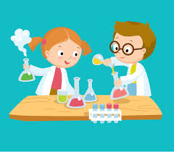

PHYSICAL EDUCATION  During Physical Education lessons in Term 3, students will be:  *Continuing to focus on the fundamental skills of kicking (soccer, football), catching and bouncing (large balls).  *Introduced to a modified game of basketball.  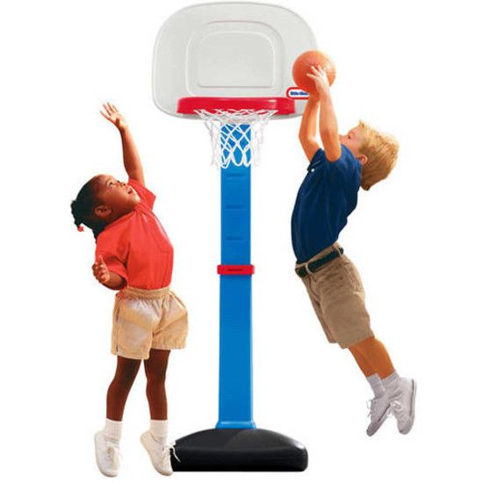  Children are encouraged to participate to the best of their ability in all the activities, challenging themselves to do their best! | DIGITAL TECHNOLOGIES  In Term 3, we will be looking at creating instructions using directional arrows to create a sequence for the computers to follow. When we return on site, these skills will help us to manually program a Bee Bot to complete an obstacle course.  We will also be discussing how to log into our own personal Google Accounts, which are managed by the school.  Through this global pandemic, I would like to wish you all the best as we resume our Remote Learning in Term Three. Stay safe!  Mr Joss
VISUAL ARTS  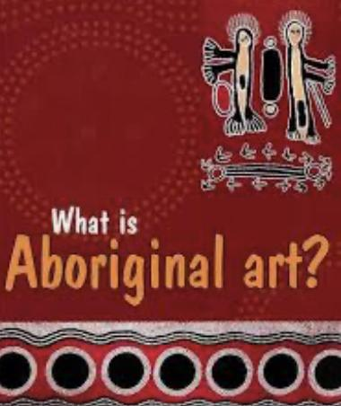  Art in Term Three will revolve around the theme of Indigenous Art. Year One students will explore the autobiographical nature of early art from our first settlers, as well as the recent contributions of their contemporary counterparts. They will complete their own art pieces and look at others with the focus of the design elements of line and pattern. | PERFORMING ARTS  In Term 3 our Year 1 students will be exploring the theme of reading simple rhythm notations. This will encompass learning the note value of music, using the language of Ta, titi and Sa.  We will also explore traditional song and finger rhymes to develop our sense of beat and rhythm.  Students will explore digital music programs including Chrome lab, completing various experiments around make and composing music..
LIBRARY  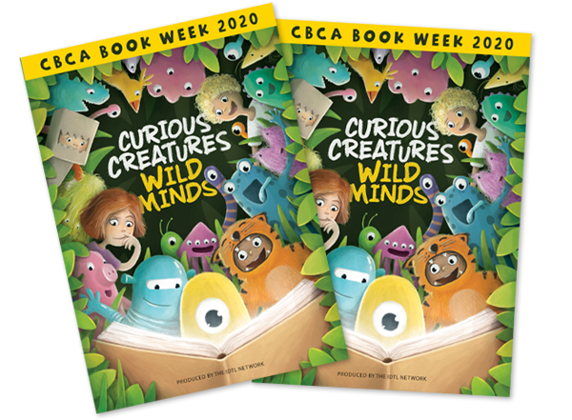  This term in Library lessons the students will be reading books selected from the 2020 CBCA shortlisted books and encouraged to vote on their favourite book. We hope all children will celebrate Book Week with the Theme being Wild Creatures Curious Minds. | ITALIAN  This term Year 1 students will  extend their knowledge of the colours in Italian. They will learn to use colors to describe known vocabulary and emotions. Students will develop an understanding of colours, emotions and greetings through rhymes, songs and a range of texts.

