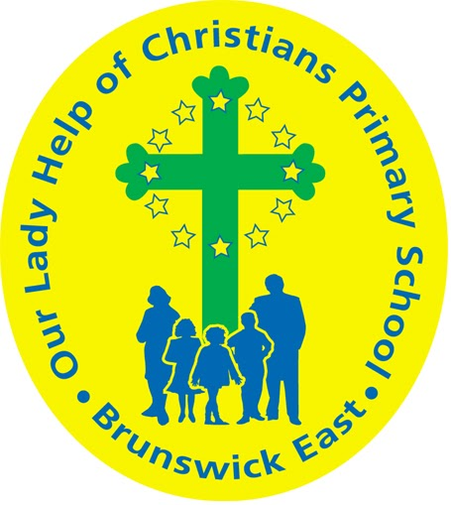
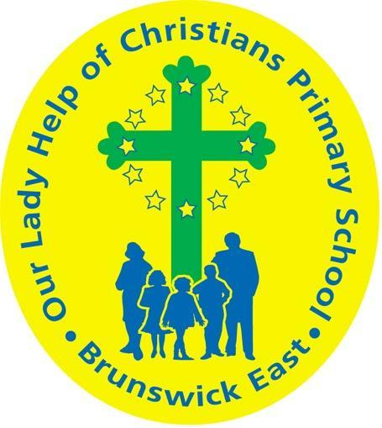
Our Lady Help Of Christians
Term 3 Overview
Year Level: 6 Teachers: Sylvia Holroyd, Nina Gualano, and Rob Lagreca .
Over the term, the children will be working towards the learning outcomes and concepts outlined below.
RELIGIOUS EDUCATION  In Religious Education, students will investigate the different types of literary texts used in Scripture. These will include examples of Letters, Gospels, Parables, Poetry, and Historical Narratives. Opportunities for connections to be made between the interpretation of these texts and personal experiences, feelings and beliefs will be provided.  Students will also compare their understanding of the meaning of these texts with the views of others in an attempt to gain new insights.  Through a study of ‘The Mass’’, students will investigate the words, actions, symbols, characters and events within various Scripture stories and relate these to the significance of the Mass. The structure of the Mass will be explored by looking at the various parts - Gathering, Story Telling, Nourishing, and Missioninl. The Catholic understanding of the Mass as a source and sign of nourishment, unity and mission will be compared with the views of others.  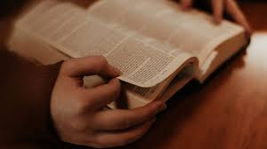 | LITERACY  This term the focus will be on scientific literature. Students will be researching famous scientists and finding out how their research helped change the world we live in today. Methods used to record scientific experiments will be explored through procedural writing. Students will be encouraged to use scientific language in their oral presentations and written work when discussing experiments.  Comprehension strategies such as finding the main idea and recalling facts and details will be investigated. Critical thinking skills will be further developed through Literature Circle activities where students will read, discuss and respond to various texts.  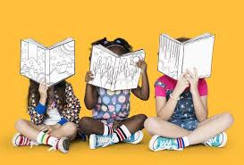
MATHEMATICS  In Number and Algebra, students will be developing their skills in the operations of multiplication and division through mental and written strategies taught. They will be required to write and solve worded problems using these operations and make links to real world situations.  In Measurement and Geometry, students will focus on converting units of measurement between common units of length, mass and capacity.  In Statistics and Probability, chance experiments will be conducted with both small and large numbers of trials.  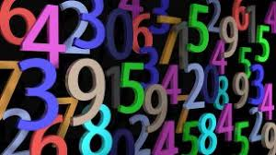 | INQUIRY  This term our Inquiry unit is about Science & Discovery. Our students will develop a deepening awareness of key scientific principles and practices and how the exploration of science changes and deepens our understanding of the world.  We will aim for students to build an understanding of the processes that can be used when undertaking scientific investigation, and of the importance of curiosity, questioning and research in finding out how things work and why things happen.

PHYSICAL EDUCATION  During Physical Education lessons in Term 3, students refine and expand their range of skills, and perform them with increasing precision, accuracy and control in more complex movements, sequences and games. The sports used to achieve this are football and netball  Students use strategic thinking, communication and cooperation to improve performance and participation.  When we return on site, they will required to work in groups, discuss ways to design or modify a simple activity or game, and consider the objective of the game, the playing conditions, the scoring and the rules and procedures for its safe conduct. They reflect on their own and others’ performances, providing appropriate feedback in order to improve skill development and game performance.  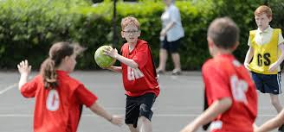 | DIGITAL TECHNOLOGIES  In Term 3, we will be using Google Software to create a website about a topic of our choice. We will be combining text, photos and videos as well as using different themes and website structures to make our projects unique.  In the second half of the term, we will be exploring Cyber Safety as we complete units from the eSmart Schools program.  Through this global pandemic, I would like to wish you all the best as we resume our Remote Learning in Term Three. Stay safe!  Mr Joss
VISUAL ARTS  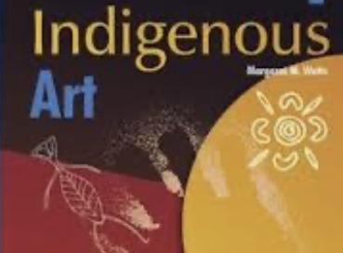  We will return to the theme of Pop Art when we are again learning on site. As such, Term Three Art will instead look at the influences of Indigenous Art. Students will explore the traditional artists, as well as their contemporary counterparts. We will study in detail the work of Aboriginal artists Jimmy Pike and Mervyn Bishop. | PERFORMING ARTS  Student’s we will be creating and writing musical compositions and performing their music to communicate ideas to an audience. The students will explore a variety of different digital music programs including incredibox, soundtrap which will enable them to further explore their understanding of the elements of music. They will be exploring different genres of music including beatboxing, acapello, electronic and indigenous music and have an understanding of what instruments are particular to these genres.  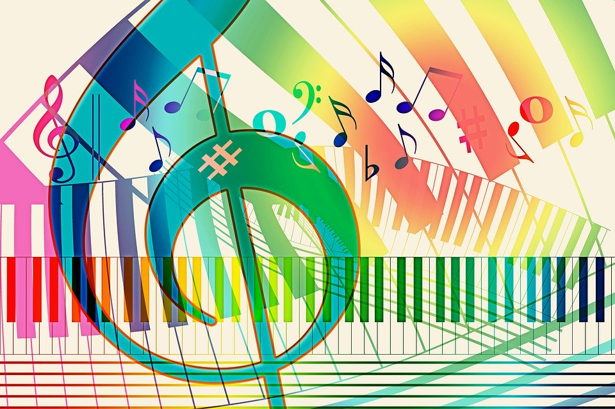
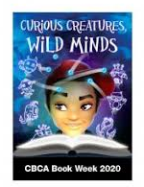  LIBRARY  This term in Library lessons the students will continue to build fluency in navigating the library with independence. They will explore a wider range of text types and find similarities and differences within each book. Especially books that have been shortlisted for the 2020 Children's Book Awards. They will explore various illustrator’s and get the opportunity to experience the life of an author and illustrator. | 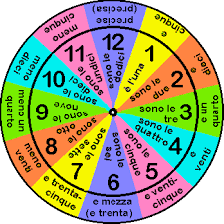  ITALIAN  We are learning how to ask the question “What time is it?” in Italian. We will learn the phrases and expressions used to respond to this question. Students will learn how to say whole hour time, minutes past and phrases used for particular times of day. Students will also be introduced to 24 hour time and its use in Italian culture.

