**Our Lady Help Of Christians**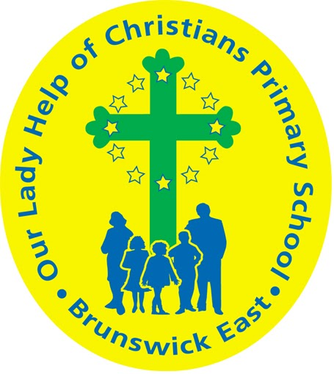

**Term One 2025 Overview**

Year Level: Two Teachers: Grace Dalla Zuanna 2 D

Teachers: Brigitte Callery ( Mon, Tues, Wed, Thurs) , Andrea Wals (Fri ) 2 C

bcallery@olbrunswickeast.catholic.edu.au gdallazuanna@olbrunswickeast.catholic.edu.au

awals@olbrunswickeast.catholic.edu.au

Over the term, the students will be working towards the learning outcomes and concepts outlined below.

| **RELIGIOUS EDUCATION**  During Term One the students will focus on the People of God and the Resurrection of Jesus. They will explore the purpose of prayer in their own lives, whilst reflecting on God’s people in the Old Testament of the Bible.  Students will learn the prayers of our Church, and begin to create their own personal prayers. Students will build their understanding on the many ways we can pray and practise these daily.  The students will be:   * exploring the purpose of prayer and identifying the key elements of a prayer space * identifying people in the Bible who had an important relationship to God and discussing the many ways we can strengthen our relationship with God * identifying Lent as a time of change when God helps people to grow to be better people * retelling the story of The Road to Emmaus and the Ascension of Jesus. | **ENGLISH**  Throughout Term One, our focus for reading is developing decoding skills using *Little Learners Love Literacy ,* an evidence-based structured literacy program. Students will revise, practise and apply skills when reading, writing, speaking and listening.  READING & VIEWING  The students will be:   * reviewing phonemes/graphemes taught in Year One * decoding unfamiliar words, including multi-syllable words * segmenting words for spelling and apply phoneme/grapheme knowledge * understanding morphology – base words, adding prefixes (un-) and suffixes (-s, -es, -ing, -er) * developing their understanding of multi-syllabic words and compound words * making text connections - *What does this story remind you of?* * responding to literal and inferential comprehension questions.   WRITING  The students will be:   * writing recounts about their experiences by focusing on the correct sequence of events * writing sentences using the Colourful Semantics approach * consolidating letter formation and placement on the dotted thirds * writing information texts * using correct punctuation * continuing to develop spelling strategies and focusing on particular spelling patterns.   SPEAKING & LISTENING  The students will be:   * speaking clearly in front of the class * listening attentively with our whole body * practising and presenting Readers Theatre plays to the class. |
| --- | --- |
| **MATHEMATICS**  NUMBER  The students will be:   * representing two and three digit numbers using MAB blocks * ordering numbers by to 1000 * partitioning and renaming numbers for example understanding that 245 is also 24 tens, 5 ones or 2 hundreds and 45 ones * solving simple addition and subtraction problems using a range of strategies.   MEASUREMENT  The students will be:   * identifying dates and the number of days in each month * reading time on an analogue clock to the hour, half hour and quarter hour * describing and demonstrating quarter, half and three quarter turns. | **INQUIRY**  Throughout the first term, students will explore their local community and recognise how to be an active member. Reflecting on the choices they can make to keep themselves safe and building on their knowledge of people in their community who keep them safe.  COMPELLING QUESTION:  *How do the places, people and symbols in our community support our safety and wellbeing?*  UNDERSTANDINGS:  Within our community there are places where we can be safe and active.  Our community has significant places that are special to us.  There are people in our community who keep us safe.  We can keep ourselves safe and healthy by making good choices and following health messages.  Relationships are key to building strong communities.  Everyone has strengths that they contribute to make communities positive places. |

| **PHYSICAL EDUCATION**  **Mr David Witchell**    In Physical Education classes this term, the students will practise and develop their skills, such as throwing and catching in small game activities. The students will also enhance their overarm throwing and striking skills through cricket activities and small games. | **STEM**  **Science, Technology, Engineering & Mathematics**  **Mrs Joanna Hanson**    In STEM in Term One, the students will learn about the fundamentals of forces and mechanics. They will observe the way different shaped objects move, depending on the size and shape of the object and the forces exerted on the object. Students will explore how different strengths of pushes and pulls affect the movement of objects and explore how these are used in the design of games. They will identify and experiment with components, such as wheels, balls, pulleys, slides and springs. Students will use Makedo Kits to invent, test and refine prototypes of their own Arcade Games, working collaboratively through the Design Process. |
| --- | --- |
| **VISUAL ARTS**  **Mrs Maegan Whiteley**    In Term One of Visual Art, Year Two students will embark on an exciting journey into the world of dots and patterns inspired by Yayoi Kusama. Through exploration, they will experiment with creating patterns using different materials, starting with drawing before progressing to three-dimensional work. Students will create patterned pumpkins using plasticine, learning how repetition and shape can transform simple objects into expressive artworks. Later in the term, they will explore cultural patterns from around the world, including Native American dreamcatchers and Scandinavian folk art, developing an appreciation for artistic traditions while experimenting with symmetry and colour. | **ITALIAN**  **Mrs Angela De Francesco**  In the unit ***La Nostra Comunità***, Our Community, students will explore the concept of community by identifying key community members and their roles in Italian. They will learn vocabulary related to various professions, such as ***medico*** doctor, ***insegnante*** teacher**,** and ***vigile del fuoco*** fireman. Through engaging activities, students will practice speaking, listening, reading, and writing in Italian, reinforcing their understanding of professions and their importance in daily life. They will also have opportunities to apply their learning in conversations, role-playing scenarios, and interactive exercises. |

| **SOCIAL and EMOTIONAL LEARNING (SEL )**  This term students will engage in the Berry Street Educational Model focusing on what it means to be ‘ready to learn’ and developing strategies to support their social/emotional development. Students will develop a ‘ready to learn plan’ and identify strategies that help their ability to learn and self regulate. They will follow the Resilience, Rights and Respectful Relationships program and explore their different character strengths and how our strengths help us to be successful.  We will also continue to remind students of the expectations and behaviours including in our Positive Behaviour for Learning Matrix. These positive behaviours will foster a shared understanding among students of how to contribute to a positive and conducive learning environment at Our Lady Help of Christians.    COMPELLING QUESTION: How do I know when I am ready to learn?  UNDERSTANDINGS:   * Managing my feelings and emotions helps me be ready to learn. * Routines help us to be ready to learn. * I know different strategies to calm me down and help me to be ready to learn. * I can identify the different emotions I feel at school. * Understanding my emotions help me to recognise when I am ready to learn or need to use strategies to help me self regulate. | **TIMETABLES**  Library Borrowing  2C & 2D: Friday   | STEM | 2C Wednesday  2D Thursday | | --- | --- | | ITALIAN | 2C Wednesday  2D Tuesday | | PHYSICAL EDUCATION | 2C Tuesday  2D Wednesday | | VISUAL ARTS | 2C Tuesday  2D Wednesday |     Have you downloaded the Seesaw App onto your device to be informed about your child’s learning?  Please contact your child’s class teacher to gain access. |
| --- | --- | --- | --- | --- | --- | --- | --- | --- | --- |