**Our Lady Help Of Christians**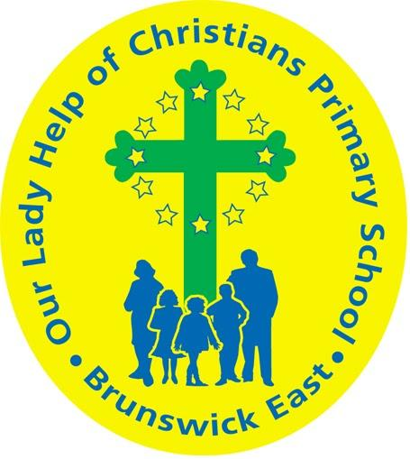

**Term One 2025 Overview**

Year Level: Four Teachers: 4S Lisa Stella & 4W Michele Witchell and Angela De Francesco

lstella@olbruswickeast.catholic.edu.au [mwitchell@olbruswickeast.catholic.edu.au](mailto:mwitchell@olbruswickeast.catholic.edu.au)

[adefrancesco@olbruswickeast.catholic.edu.a](mailto:adefrancesco@olbruswickeast.catholic.edu.au)u

Over the term, the students will be working towards the learning outcomes and concepts outlined below.



| **RELIGIOUS EDUCATION**  Students will be extending their learning about prayer and how it helps form our relationship with God. Jesus specifically emphasised the importance of prayer in our daily loves. Students will participate and reflect on their experiences of prayer and explain the role of prayer in their lives. They will interpret the significance of symbols, rituals and the sacred in relation to prayer experiences. Students will reflect on personal and school community practices and preferences for prayer.  Students will explain the relationship between God, Jesus and the Holy Spirit as expressed in the New Testament.  They will interpret and explore God's loving forgiveness through the story of Jesus’ life, death and resurrection.  The students also consider the presence of God in the world and unpack the three elements of Lent: prayer, fasting and almsgiving. | **ENGLISH**  READING & VIEWING  The students will be:   * identifying features used in imaginative and persuasive texts * discussing how authors and illustrators make stories exciting, moving and hold readers interest * using comprehension strategies to develop literal and inferred meaning of texts by expanding content knowledge, linking ideas and analysing information.   WRITING  The students will be:   * organising ideas and actions into paragraphs, corresponding to the stages of the texts they write to provide detailed information about settings, character motives, and actions for imaginative purposes * developing understanding of conjunctions within sentences, and as connectives to link ideas across sentences, ensuring cohesion in text features for multiple purposes * demonstrating sentence-level grammar skills by employing simple, compound, and complex sentences of varying lengths to enhance variation and cohesion * demonstrating correct use of apostrophes, verb tenses and question marks * experimenting with the second-person narrative voice for effect in imaginative purposes.   SPEAKING & LISTENING  The students will be:   * discussing literary experiences with others, sharing responses and expressing a point of view * developing skills of cooperation when engaged in conversation. |
| --- | --- |
| **MATHEMATICS**  NUMBER  The students will be:   * understanding the concept of odd and even numbers * identifying and categorising numbers as odd or even * learning to read and write numbers up to thousands using place value * solving problems involving estimation to enhance mathematical reasoning * recognising and creating patterns involving doubling and halving * practising problem-solving using doubling and halving strategies.   ALGEBRA  The students will be:   * exploring the relationship between multiplication and division through patterns * working with multiplication facts up to 10x10 and related division facts.   MEASUREMENT  The students will be:   * using scaled and digital instruments to interpret unmarked and partial units to measure and compare lengths.   SPACE  The students will be:   * recognising line and rotational symmetry of shapes and creating symmetrical patterns and pictures.   STATISTICS & PROBABILITY  The students will be:   * identifying and discussing events that commonly occur in daily life * understanding the concept of events and their likelihood * exploring various situations where outcomes are uncertain * applying the knowledge to solve problems involving the probability of events. | **INQUIRY**  COMPELLING QUESTION:  Who makes decisions in our community and how are they made?  Students will explore how Australia is a democratic nation where citizens elect leaders to make important decisions. They will learn about the role of local government in keeping communities safe and running smoothly. Students will also investigate the importance of rules and laws in maintaining order and fairness. Additionally, they will explore how individuals can contribute to their communities by identifying needs, solving problems, and making positive changes.  UNDERSTANDINGS:   * Australia is a democratic nation where citizens elect people to make decisions. * Local governments are elected to make decisions to keep our communities functioning and safe. * Within a community there are rules and laws that keep law and order. * Citizens contribute to their communities by identifying needs and solving problems to create positive change. |

| **PHYSICAL EDUCATION**  **Mr David Witchell**    In Physical Education classes this term, the students will continue to develop basic skills such as overarm throwing, striking and catching through small activities and modified games. The students will also begin focussing on Athletics in Term One and will participate in running, jumping and throwing activities. These activities will be in preparation for the athletics trials in Term Two. | **Science, Technology, Engineering & Mathematics**  **Mrs Jo Hanson**    In STEM in Term One, the students will explore forces such as gravity, tension and compression by investigating the effect of these forces on the behaviour of objects. They will identify and explore properties and relationships of engineered structures, by constructing and testing cardboard chairs and spaghetti bridges. Students will investigate materials, tools and equipment to discover characteristics and properties. They will explore architecture and compare how buildings were constructed in the past and present, taking note of engineering innovations. The students will be introduced to Tinkercad and work collaboratively to generate, develop and communicate design ideas using this platform. Students will develop their skills in negotiation and planning effectively as a team. |
| --- | --- |
| **VISUAL ARTS**  **Mrs Maegan Whiteley**    In Term One of Visual Art, Year Four students will explore optical illusions and reflections through Yayoi Kusama’s use of dots, symmetry and repetition. They will create individual and group artworks, including symmetrical dot patterns and ‘mini infinity boxes’, while experimenting with reflections. Students will also learn about the cultural significance of pom-poms in Latin American art, designing their own colourful pom-poms inspired by Peruvian and Mexican textiles. This term will foster creativity, pattern-making, and cultural exploration through hands-on projects and collaborative activities. | **ITALIAN**  **Mrs Angela De Francesco**    Students will learn and use the Italian language to engage in various games. They will acquire phrases for inviting others to play, taking turns, and asking and answering questions. Additionally, they will revisit their knowledge of numbers and apply it during gameplay. Through exposure to various texts, they will explore game rules and the language needed for participation. |

| **SOCIAL and EMOTIONAL LEARNING ( SEL )**  COMPELLING QUESTION:  What role do personal values play in shaping identity and community?  UNDERSTANDINGS:   * Knowing your values helps you understand your identity. * Values can help us to connect with each other and the community in meaningful ways. * To build relationships within our communities, we share and acknowledge our strengths.   Throughout our SEL unit this semester, students will be undertaking lessons supported by the Berry Street Education Model (BSEM). These lessons are designed to support the development of student's physical, psychological, social and emotional capacities. Our SEL unit will help increase engagement, improve all students’ self-regulation, well being, growth and academic achievement.    Using the Rights, Resilience and Respectful Relationship  curriculum, students will understand emotional literacy and the times when their emotions respond to situations. | **TIMETABLES**     | Library Borrowing | | | --- | --- | | 4S | Friday | | 4W | Friday |  | Specialists | | | --- | --- | | STEM | Wednesday | | ITALIAN | Tuesday | | PHYSICAL EDUCATION | Wednesday | | VISUAL ARTS | 4W Tuesday  4S Thursday |     Have you downloaded the Seesaw App onto your device to be informed about your child’s learning?  Please contact your child’s class teacher to gain access. |
| --- | --- | --- | --- | --- | --- | --- | --- | --- | --- | --- | --- | --- | --- | --- | --- | --- | --- |