**Our Lady Help Of Christians**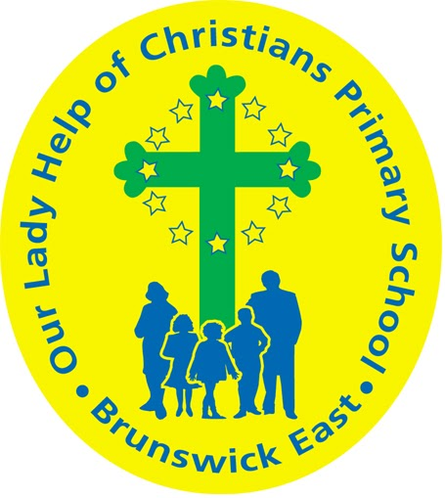

**Term One 2025 Overview**

Year Level: Five Teachers: Lana Brockenshire 5B & Brody Hill 5H

[lbrockenshire@olbruswickeast.catholic.edu.au](mailto:lbrockenshire@olbruswickeast.catholic.edu.au)  [bhill@olbruswickeast.catholic.edu.au](mailto:bhill@olbruswickeast.catholic.edu.au)

Over the term, the students will be working towards the learning outcomes and concepts outlined below.

| **RELIGIOUS EDUCATION**  The students will be learning about the development of the Catholic Church in Australia. Students will investigate key people who have helped or are currently helping to shape the Church. They reflect on how the Holy Spirit inspires individuals and organisations to spread God’s justice and goodness and some of the ways that Catholics contribute to Australian society.  The students will be:   * investigating people in Australia’s Catholic Church, both past and present, who inspire others * researching how the Catholic Church serves communities.   Students will be learning **h**ow Lent and Easter are a time of waiting and preparing. They will be looking at  the signs, symbols, rituals, prayers and practices associated with Easter. Students will be reminded how we can be part of Jesus’ sacrifice today.  The students will be:   * explaining the development of signs, symbols, rituals, prayers and practices associated with the Church’s liturgical calendar * interpreting the significance of liturgical signs, symbols, colours, rites, rituals and sacraments in the past and present Church. | **ENGLISH**  READING & VIEWING  The students will be:   * using reading material to prepare for NAPLAN * analysing the text structures and language features used in imaginative and persuasive texts * developing comprehension strategies including finding the main idea of a text, cause and effect and inferring * using comprehension strategies, such as visualising, predicting, connecting, summarising, monitoring and questioning, to evaluate information and ideas to build literal and inferred meaning.   WRITING  The students will be:   * planning, drafting and editing narrative and persuasive texts in preparation for NAPLAN * looking in detail at the structure and language features of narrative and persuasive texts * creating criteria for editing, focussing on sequence, punctuation and spelling * practising fluency, style and correct letter formation, when handwriting.   SPEAKING & LISTENING  The students will be:   * developing strategies to contribute actively to class and group discussions * presenting and justifying a point of view. |
| --- | --- |
| **MATHEMATICS**  This term, students will engage in a range of mathematical concepts to develop their understanding and problem-solving skills.  Number  The students will be:   * developing efficient strategies for multiplication and division * explaining different strategies when completing multiplication problems * researching divisibility tests and explaining each rule using materials.   Measurement  The students will be:   * exploring units of length, perimeter and area of regular and irregular shapes * solving practical problems involving the perimeter and area of regular and irregular shapes using appropriate metric units.   Statistics  The students will be:   * collecting and interpreting data using tables and graphs * analysing trends and making predictions based on data.   Throughout the term, students will apply their learning through hands-on activities, problem-solving tasks, and real-world applications to strengthen their mathematical thinking. | **INQUIRY**  In Term One, Year Five students will explore the values and key features of Australia’s democratic system. They will learn about the three levels of government, how laws are made and enforced and the roles and responsibilities of key institutions in our society. Through investigating contemporary issues, students will develop questions, analyse different sources, and consider the importance of active participation in democratic processes. Students will develop a deeper understanding of citizenship, including the rights and responsibilities that come with being part of a democratic nation.  **COMPELLING QUESTION:**  Who does what in Australia's democracy, and why does it matter?  UNDERSTANDINGS:   * Australia is a democracy with three levels of government. * The democratic process enables governments to represent the views and values of the community. * Parliaments are responsible for creating laws in Australia. * Communities are made up of individuals who make contributions. |

| **PHYSICAL EDUCATION**  **Mr David Witchell**    In Physical Education classes this term, the students will expand their range of skills and will participate in various physical activities to help improve their fitness. The students will also further develop their overarm throwing and striking skills through cricket activities and small games. The students will also prepare for the District Athletics trials in Term Two by participating in sprints, long distance running, jumping events and throwing events. | **STEM**  **Science, Technology, Engineering & Mathematics**  **Mrs Joanna Hanson**    In STEM in Term One, students will develop their ability to work collaboratively in teams, with a focus on respecting and valuing the contributions of others. Students will communicate design ideas using modelling and drawing techniques in the program Tinkercad. The students will build circuits and learn about conductivity of materials. They will investigate how moving air can turn turbines to generate electricity and how solar panels generate electricity. Students will work through a Design Sprint, where they improve upon current designs of wind farms and solar panels to make them more practical and aesthetically pleasing. |
| --- | --- |
| **VISUAL ARTS**  **Mrs Maegan Whiteley**    In Term One of Visual Art, Year Five students will immerse themselves in the world of Yayoi Kusama, focusing on her use of dots, repetition, and infinity. They will explore Kusama’s unique style through a series of activities, including creating abstract self-portraits using dots and patterns, and designing an installation inspired by Kusama’s Obliteration Rooms. Students will also learn about cultural architecture by studying iconic structures such as the Taj Mahal and the Great Wall of China. They will plan and create their own World City sketch, incorporating buildings from different cultures. This term will encourage creativity, collaboration and cultural exploration. | **ITALIAN**  **Mrs Angela De Francesco**    Students will undertake a unit of work called ***I Romani***, The Romans.  This unit will complement the Inquiry topic by comparing the experiences of people from Ancient Rome with those of the students today.  Students will explore what it might have been like to live in Ancient Rome, focusing on the social structure and government of the time.  They will also develop their Italian vocabulary and use of simple sentences to describe life in Ancient Rome. |

| **SOCIAL and EMOTIONAL LEARNING (SEL)**  In Term One our focus on Social-Emotional Learning (SEL) includes explicit lessons centred around the Positive Behaviour for Learning Matrix. These sessions are designed to empower students to master the specific behaviours outlined in our matrix. Through interactive activities and guided discussions, students will not only understand how these behaviours shape our learning environment but also recognise their role in shaping our collective identity as a school community. These sessions will facilitate a deeper understanding of the positive behaviours expected at OLHC, fostering a shared understanding among students. By engaging in this structured exploration, students will develop the skills and awareness needed to contribute to a positive and conducive learning environment at Our Lady Help of Christians.    COMPELLING QUESTION: How do our behaviours shape our learning environment?  UNDERSTANDINGS:   * The way we behave (being kind, listening, and working together) makes our classroom a better place to learn. * When we are respectful and helpful, learning becomes more enjoyable for everyone. * Encouraging and supporting each other builds confidence and makes it easier to try new things. * Taking care of our materials, completing our work, and following rules help keep our learning environment organized and fun. | **TIMETABLES**  Library Borrowing  5B: Monday  5H: Monday   | STEM | Monday | | --- | --- | | ITALIAN | Thursday | | PHYSICAL EDUCATION | Monday | | VISUAL ARTS | Thursday |     Have you downloaded the Seesaw App onto your device to be informed about your child’s learning?  Please contact your child’s class teacher to gain access. |
| --- | --- | --- | --- | --- | --- | --- | --- | --- | --- |