**Our Lady Help Of Christians**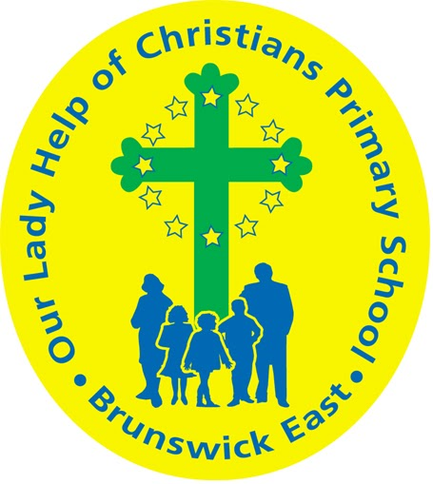

**Term Two 2025 Overview**

Year Level: Six Teachers: Mary Papworth 6P mpapworth@olbruswickeast.catholic.edu.au

Nyree Clyne 6C Mon - Thurs nclyne@olbruswickeast.catholic.edu.au

Damien Murray 6C Friday dmurray@olbruswickeast.catholic.edu.au

Over the term, the students will be working towards the learning outcomes and concepts outlined below.

| **RELIGIOUS EDUCATION**  Inspired by The Beatitudes (Mt 5:1–12; Lk 6:20–26), this term the students will explore Social Justice in **a Community of Faith.** Students will be invited to consider what it means to be part of a faith community committed to justice and service. Students will reflect on the life of Pope Francis, who called on us to serve others. Students will unpack Pope Francis’s messages and teachings, learn about his passing and the election of a new Pope to lead our Church. Students will examine the lives of individuals who embody faith through action—locally, nationally, and globally.  The students will be:   * exploring the significance of being members of the Church * interpreting what it means to belong to the Catholic Church or other faith communities * considering their roles and responsibilities in building a just and compassionate community. | **ENGLISH**  READING & VIEWING  The students will be:   * developing comprehension strategies including comparing and contrasting, classifying facts   and opinions to interpret texts, inferring and  identifying author’s purpose   * making connections between our life and characters lives, between different texts we have read, between texts we read and world events.   WRITING  The students will be:   * planning, drafting and editing narrative and information texts * looking in detail at the structure and language features of narrative and information texts * organising their thinking and ideas for writing by using a Writer’s Notebook * creating an editing criteria focussing on sequence, punctuation and spelling * practising fluency, style and correct letter formation when handwriting * using a range of strategies to spell more complex words.     SPEAKING & LISTENING  The students will be:   * listening attentively and respectfully to others * engaging in class discussions by offering insightful comments that help to question, develop or support the ideas of others * planning, rehearsing and delivering presentations with supporting visual displays. |
| --- | --- |
| **MATHEMATICS**  NUMBER  The students will be:   * solving problems using the four processes and rounding and estimating for computations * using efficient mental, written strategies exploring techniques for multiplication and division * continuing and creating sequences involving whole numbers, fractions and decimals * comparing and ordering fractions and decimals and showing them on a number line.   MEASUREMENT  The students will be:   * measuring, comparing and calculating elapsed time * recognising the equivalence of measurements between centimetres and metres.   SPACE  The students will be:   * investigating the properties of shapes, including lines of symmetry * connecting three-dimensional objects with their nets and other two-dimensional representations * constructing prisms and pyramids from nets and models and finding the cross-section of three-dimensional objects.   PROBABILITY  The students will be:   * listing outcomes of chance experiments involving equally likely outcomes * representing probabilities using fractions, decimals and percentages.   STATISTICS  The students will be:   * displaying the results of chance experiments as tables, charts and graphs * analysing the results and forming statements to match the data gathered. | **INQUIRY**  This term, students will investigate how plants and animals adapt to different habitats and how changes in the environment affect their survival. They will explore human impacts, such as deforestation and climate change, and learn how conservation efforts can protect ecosystems. Through hands-on activities and research, students will build their understanding of the relationships between living things and their environments.  COMPELLING QUESTION: Saving Wildlife: How can we stop extinction?    UNDERSTANDINGS:   * Different plants and animals thrive in different habitats because they have adapted to specific environmental conditions. * When the physical conditions of a habitat change, it can directly affect the growth, reproduction, and survival of organisms. * Humans have an impact on the survival of species. * Humans can make a difference by working on conservation efforts. * Researchers are curious about the world and use a variety of skills to gather and organise information. |

| **PHYSICAL EDUCATION**  **Mr David Witchell**      During the first two weeks of Term Two, the students in Year Six will continue to focus on athletic skills, such as throwing, jumping and running. This is in readiness for the athletics carnival in early Term Two. The students will be focussing on skills of Australian Rules Football and basketball. They will have an opportunity to perform these skills in small games and competitive group situations. The students will understand the importance of physical activity and keeping fit and active. The students will also have an opportunity to represent the school in Inter School Sport and the Brunswick District Cross Country Carnival. | **STEM**  **Science, Technology, Engineering & Mathematics**  **Mrs Joanna Hanson**    In STEM in Term Two, the students will participate in the Merribek inter school STEM Mad Challenge. The challenge gives students the opportunity to design, create and present prototypes that aim to solve real world problems. Through collaboration and the Design Process, students will explore how to make a positive impact on individuals, communities and societies. The focus for our learning through this unit will be on communication of scientific and design ideas and documenting the process of prototype creation. Students will record their ideas and findings using digital tools and platforms as well as scientific vocabulary. |
| --- | --- |
| **VISUAL ARTS**  **Mrs Maegan Whitleley**    In Term Two, in Visual Art, Year Six students will create a soft toy as a personalised gift for their Prep buddies. This project is designed to build foundational sewing skills and explore design techniques. Each student will use a drawing by their Prep buddy as inspiration, incorporating elements such as colour, shape and texture to bring the sketch to life. As part of the design process, students will plan their toy through initial sketches and select suitable fabrics that reflect the visual qualities of the original drawing. They will then learn and apply basic hand-sewing techniques, including a running stitch, backstitch, and overcast stitch, to construct their soft toy. | **ITALIAN**  **Mrs Angela De Francesco**    Students will identify and use Italian vocabulary related to animal species and habitats. They will focus on Italian wildlife, and describe animals using simple Italian sentences. Students will read short Italian texts about animals and their environments. They will present short projects in Italian on specific animals or ecosystems. |

| **SOCIAL and EMOTIONAL LEARNING ( SEL )**  In Term Two, our focus on Social-Emotional Learning (SEL) includes explicit lessons centred around the Positive Behaviour for Learning Matrix. These sessions are designed to empower students to master the specific behaviours outlined in our matrix. Through interactive activities and guided discussions, students will not only understand how these behaviours shape our learning environment but also recognise their role in shaping our collective identity as a school community.  This term, students will also take part in the Carlton Respects program, which promotes respect, equality and healthy relationships. Through age-appropriate discussions and activities, students will explore the importance of treating others with kindness, understanding different perspectives, and standing up for what is right. The program supports our school’s commitment to creating a safe and inclusive environment for all.    COMPELLING QUESTION: How can I be the best version of myself?  UNDERSTANDINGS:   * As I grow and become more mature I need to have a greater awareness of myself and others. * Personal growth happens by taking risks and challenging myself in new situations. * Active listening and compromising with others, creates positive outcomes. | **TIMETABLES**  Library Borrowing: Monday   | STEM | Tuesday | | --- | --- | | ITALIAN | Tuesday | | PHYSICAL EDUCATION | Thursday | | VISUAL ARTS | Thursday |     Have you downloaded the Seesaw App onto your device to be informed about your child’s learning?  Please contact your child’s class teacher to gain access. |
| --- | --- | --- | --- | --- | --- | --- | --- | --- | --- |